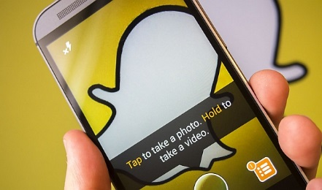
Snapchat

Safety Tips and Resources
Staying safe on Snapchat is everyone's responsibility – see below for some helpful tips and resources!
- Be kind and respectful. Be thoughtful about what you Snap and don't send people things they don't want to receive.
- Remember, anyone can take a screenshot of a Snap, or simply use another camera to take a picture of a Snap that appears on their screen. It’s also worth noting that Story viewers or Snap recipients may be able to remove effects (like doodles and stickers) from your Snaps if they’re using a jailbroken phone or other means. It’s best not to use a doodle to cover up anything you wouldn’t want friends to see.
- Check your privacy settings to choose who can send you Snaps and view your Stories.
- If you experience harassment or bullying, block the person and report it to us. Also, check out ConnectSafely's information on cyberbullying.
- Keep your password safe. Don't share your password with other people, applications, or websites. Use a different password for every service you use.
- Read our Community Guidelines and help your friends follow them as well. If you experience something upsetting, let us know and tell a parent or trusted adult.

Reporting:
https://support.snapchat.com/en-US/i-need-help

