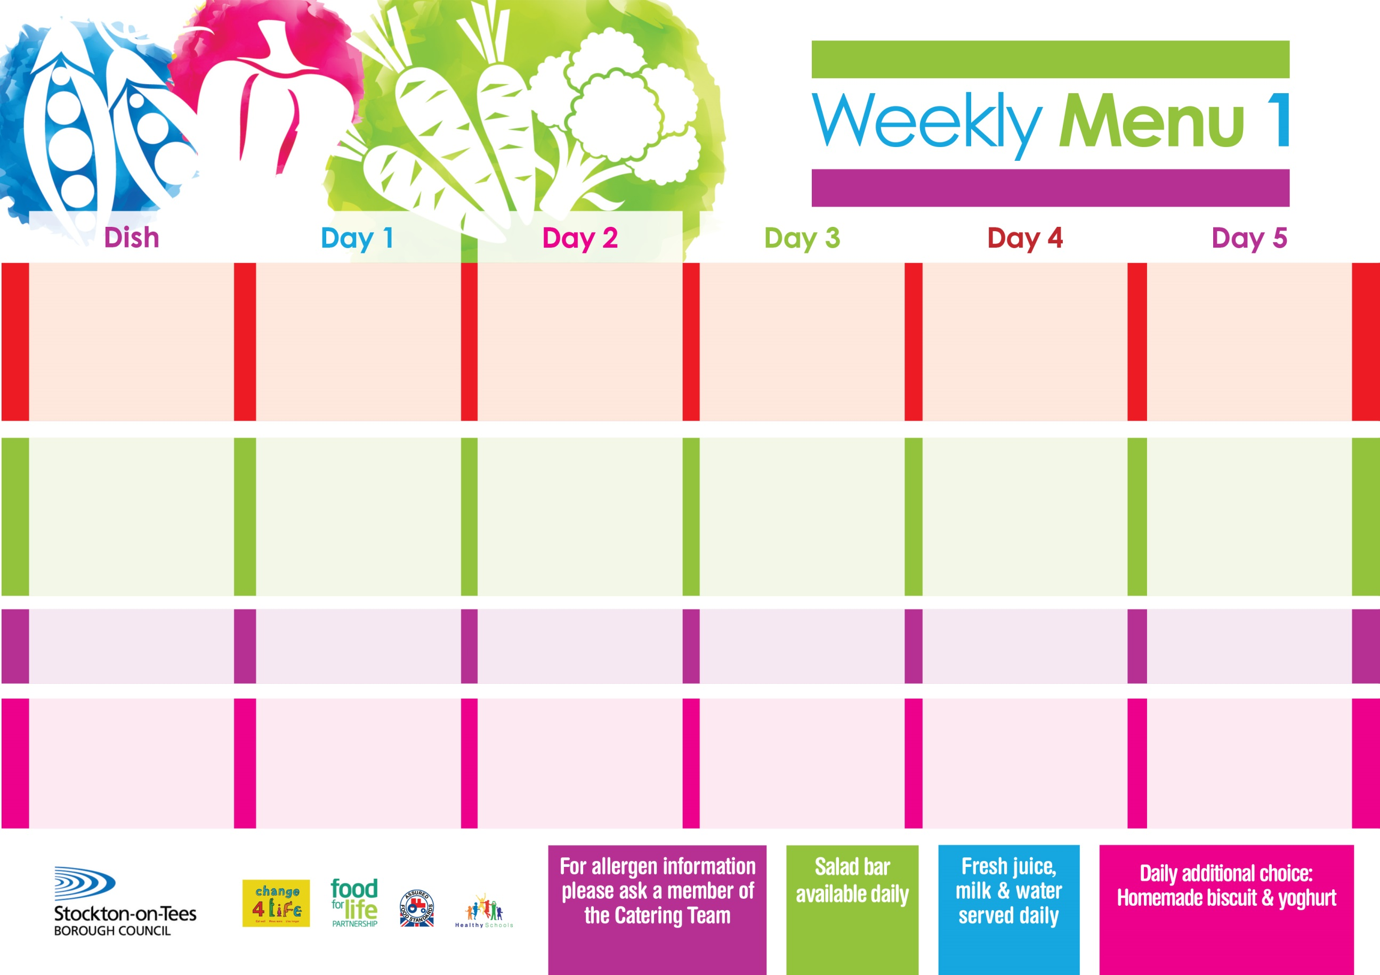

**3rd January, 31st January, 7th March & 4th April, 2022**

**Roast Turkey served with Sage & Onion Stuffing**

**Salmon & Sweet Potato Fishcake/Fishcake**

**Sliced Roast Ham**

**Variety of Sandwiches & Wraps: -**

**Cheese (V), Tuna & Egg (V)**

**Homemade Quiche**

**Creamed Potatoes**

**Baby Boiled Potatoes**

**Cauliflower/ Baton Carrots**

**Spaghetti Hoops**

**Feathered Sponge**

**with Custard Sauce**

**Cold Bar**

**Watermelon Slices**

**Chicken Curry**

**Or**

**Quorn Curry (V)**

**Fish Fillet Fingers**

**Sliced Roast Ham**

**Variety of Sandwiches & Wraps: -**

**Cheese (V), Tuna & Egg (V)**

**Homemade Quiche**

**Oven Baked Potato Wedges**

**Rice**

**Mixed Vegetables**

**Baked Beans**

**Chocolate Sponge**

**with Custard Sauce**

**Cold Bar**

**Melon Boat**

**Toad In The Hole**

**Jacket Potato filled with Tuna, Cheese (V) or Baked Beans (V)**

**Sliced Roast Ham**

**Variety of Sandwiches & Wraps: -**

**Cheese (V), Tuna & Egg (V)**

**Homemade Quiche**

**Oven Roasted Potatoes**

**Oven Baked Jacket Potato**

**Broccoli**

**Diced Swede**

**Syrup Roly Poly**

**with Custard Sauce**

**Cold Bar**

**Fresh Fruit Salad**

**Harry Ramsden Fish Fillet**

**Pizza Whirls (V)**

**Sliced Roast Turkey**

**Variety of Sandwiches & Wraps:-**

**Cheese (V), Tuna & Egg (V)**

**Homemade Quiche**

**Oven Baked Chips**

**Garden Peas**

**Baked Beans**

**Rice Pudding**

**with Jam Sauce**

**Cold Bar**

**Fresh Fruit Platter**

**Minced Beef & Dumplings**

**Penne Pasta in**

**Tomato Sauce (V)**

**Sliced Roast Turkey**

**Variety of Sandwiches & Wraps: -**

**Cheese (V), Tuna & Egg (V)**

**Homemade Quiche**

**Homemade Garlic Bread**

**Creamed Potatoes**

**Diced Carrots**

**Garden Peas**

**Apple Crumble**

**with Custard Sauce**

**Cold Bar**

**Fresh Fruit Bowl**

**Primary School Menus**

**Traditional Fayre**

**Cold Selection**

**Potatoes & Vegetables**

**Desserts**