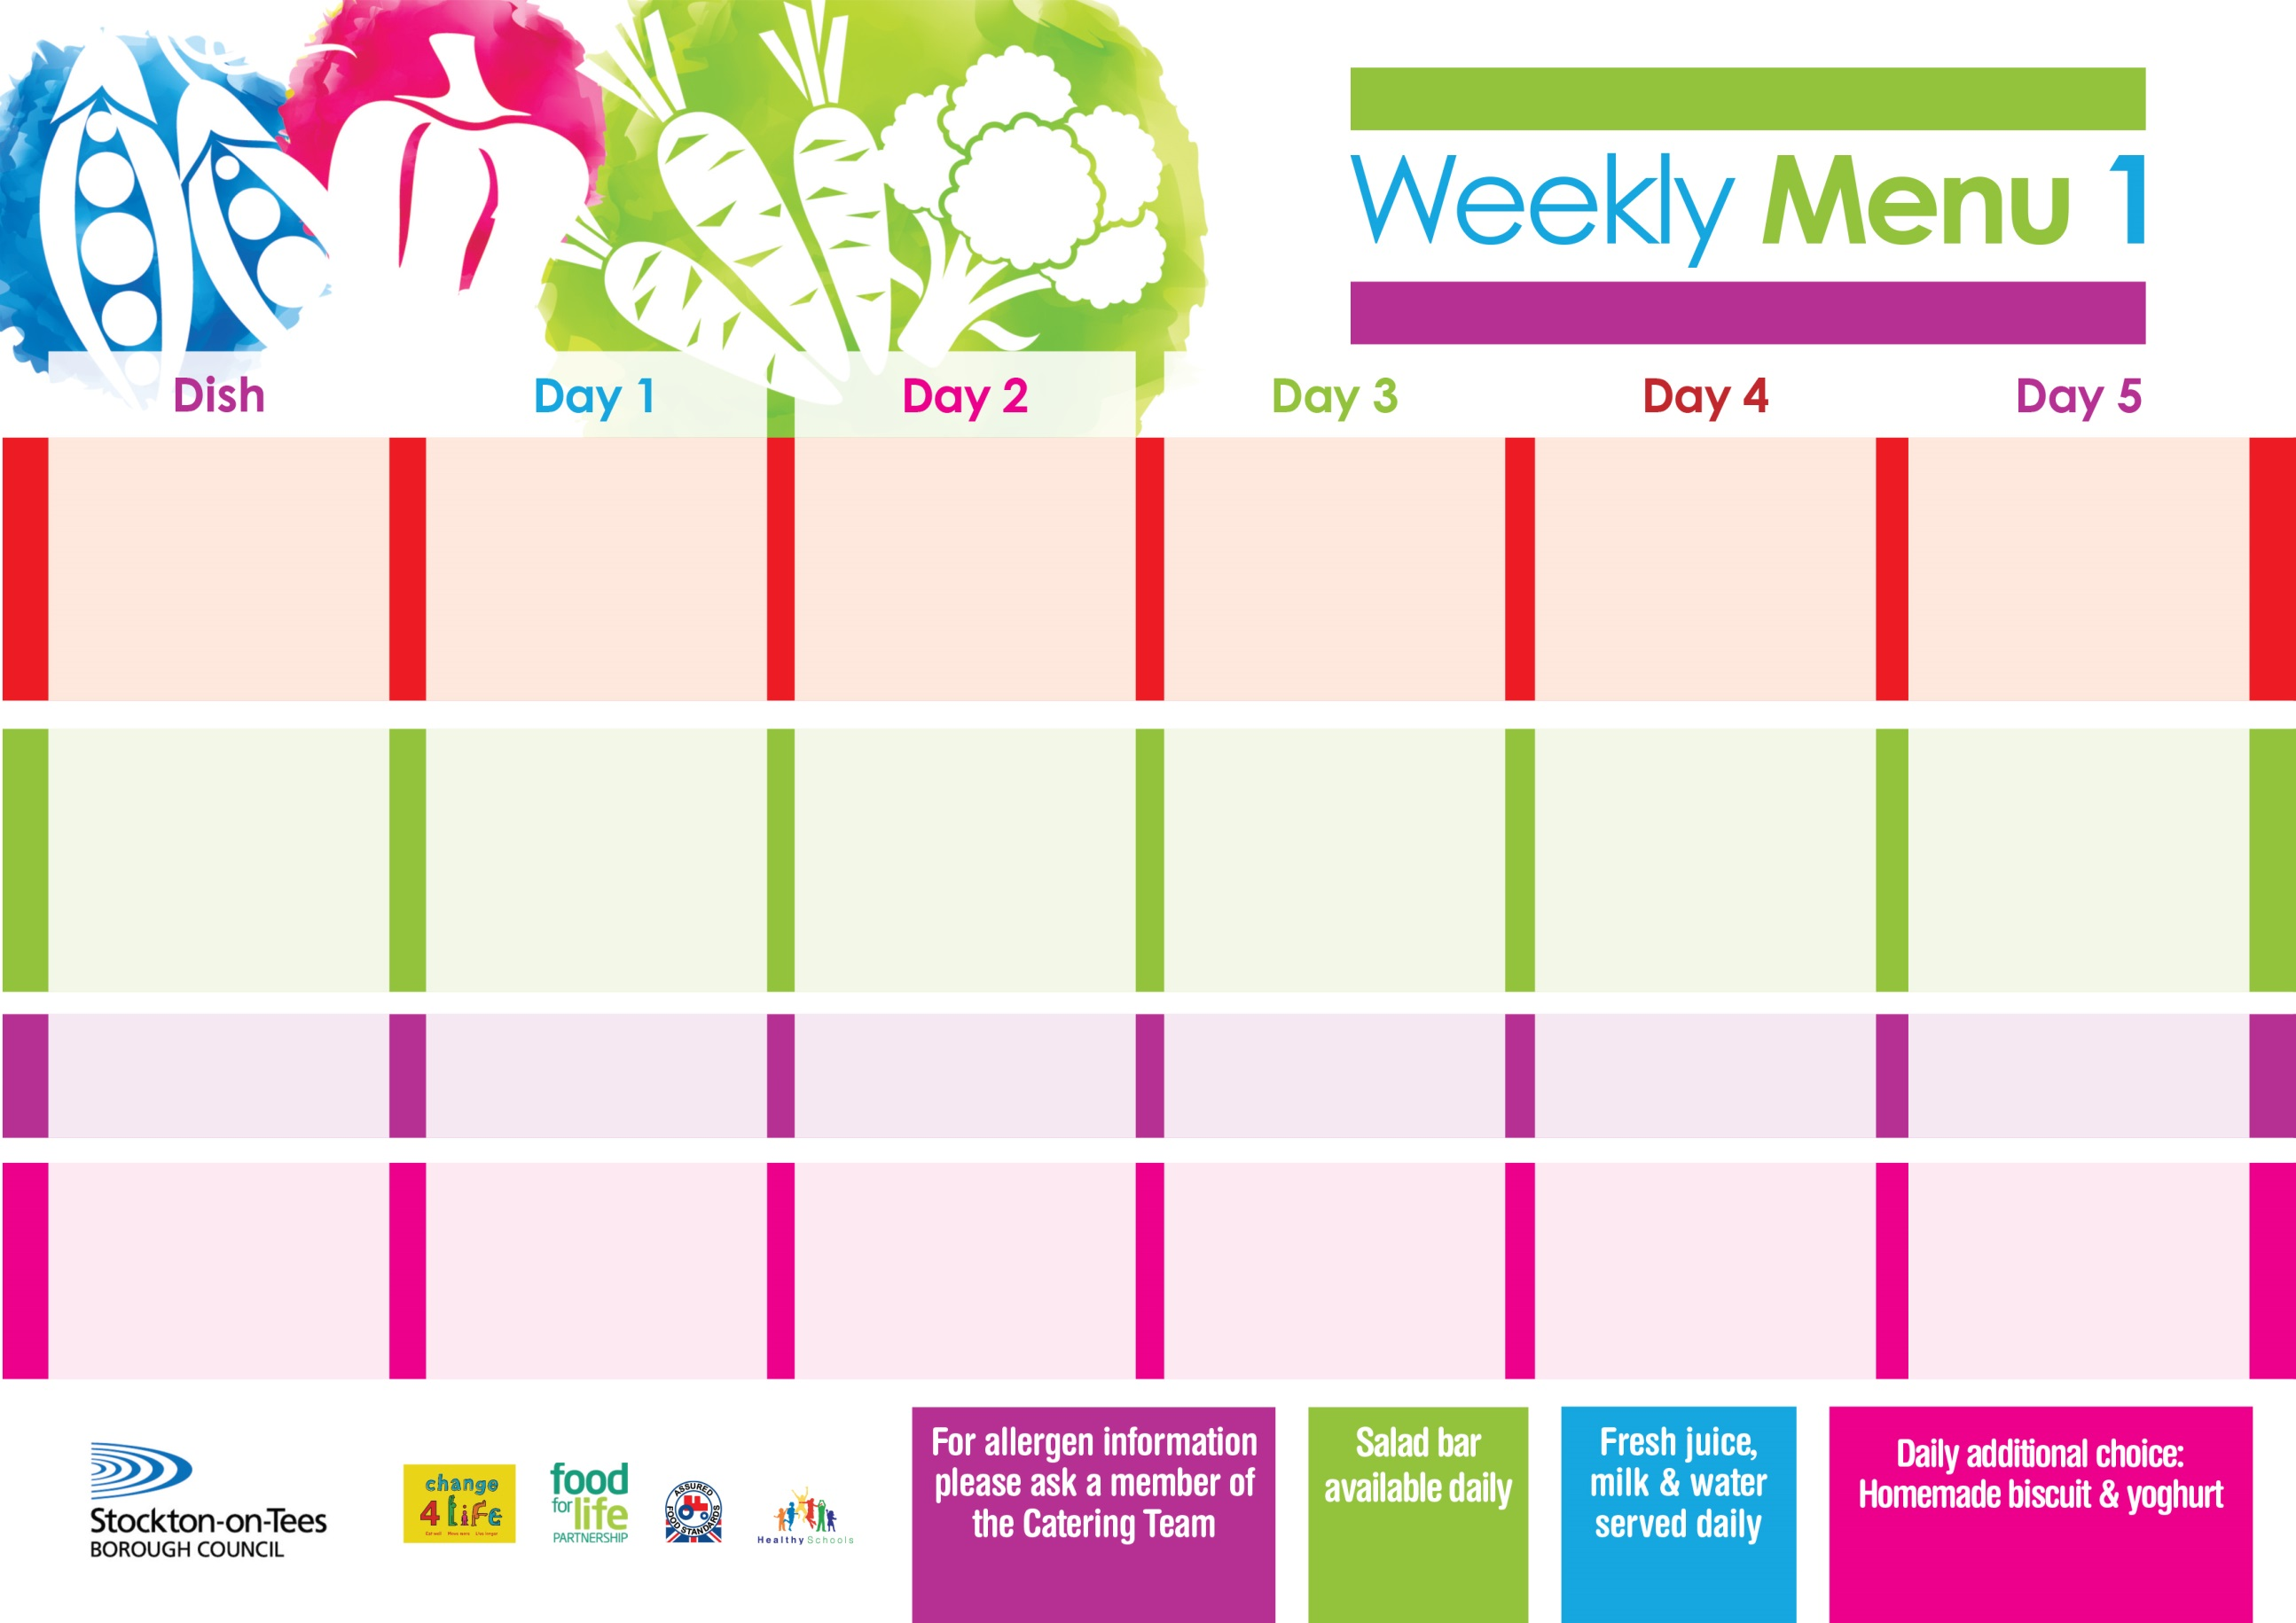

**1st January, 29th January & 4th March, 2024**

**Roast Gammon served with Pineapple**

**Baked Jacket Potatoes**

**Tossed Salad & Coleslaw**

**Mini Cheese & Onion Slice (V)**

**Baked Jacket Potatoes**

**Spaghetti Hoops**

**Variety of Sandwiches**

**Cheese (V), Tuna & Egg (V)**

**Chocolate Crunch**

**with Custard Sauce**

**Cold Bar**

**Fresh Fruit Salad**

**Mince & Dumplings**

**Baby Boiled Potatoes**

**Diced Carrots**

**Cauliflower**

**Fish Star**

**Baby Boiled Potatoes**

**Diced Carrots**

**Cauliflower**

**Variety of Sandwiches**

**Cheese (V), Tuna & Egg (V)**

**Apple Crumble**

**with Custard Sauce**

**Cold Bar**

**Fresh Fruit**

**Macaroni Bake (V)**

**Homemade Garlic Bread**

**Broccoli**

**Mixed Vegetables**

**Jacket Potato filled with Tuna, Cheese (V) or Baked Beans (V)**

**Variety of Sandwiches**

**Cheese (V), Tuna & Egg (V)**

**Ginger Sponge**

**with Custard Sauce**

**Cold Bar**

**Fresh Fruit Salad**

**Harry Ramsden Fish Fillet**

**Oven Baked Chips**

**Garden Peas**

**Baked Beans**

**Homemade Pizza (V)**

**Baked Potato Wedges**

**Baked Beans**

**Variety of Sandwiches**

**Cheese (V), Tuna & Egg (V)**

**Vanilla Sponge**

**with Custard Sauce**

**Cold Bar**

**Fresh Fruit**

**Breaded Chicken Breast**

**Oven Roasted Potatoes**

**Sweetcorn**

**Garden Peas**

**Corned Beef Pie**

**Oven Roasted Potatoes**

**Sweetcorn**

**Garden Peas**

**Variety of Sandwiches**

**Cheese (V), Tuna & Egg (V)**

**Chocolate Sponge**

**with Custard Sauce**

**Cold Bar**

**Fresh Fruit**

**Primary School Menus**

**Traditional Fayre**

**Cold Selection**

**Desserts**