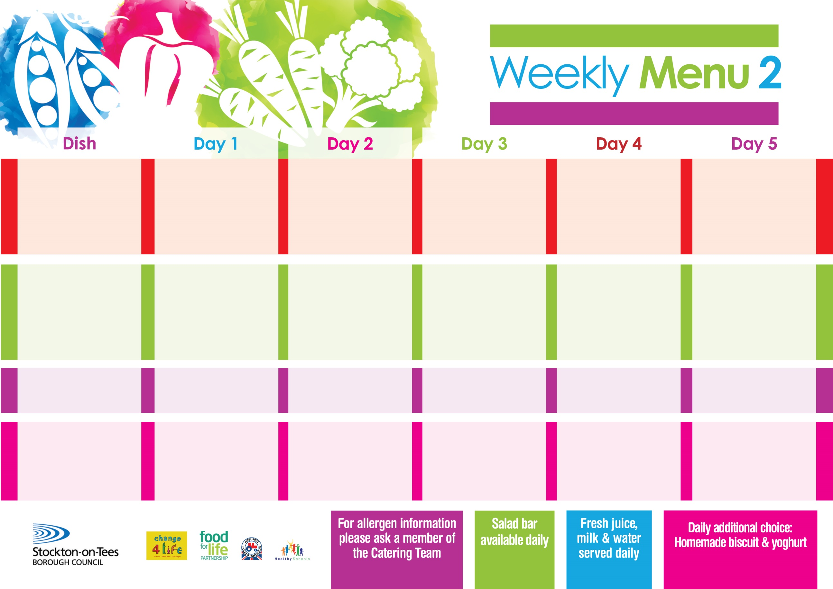

**2nd May, 6th June & 4th July, 2022**

**Minced Beef & Yorkshire Puddings**

**Creamed Potatoes**

**Cabbage**

**Mixed Vegetables**

**Baked Sausages**

**OR**

**Baked Quorn Sausages (V)**

**Oven Roasted Potatoes**

**Spaghetti Hoops**

**Variety of Sandwiches**

**Cheese (V), Tuna & Egg (V)**

**Homemade Quiche**

**Apple Pie**

**with Custard Sauce**

**Cold Bar**

**Fresh Fruit Bowl**

**Breaded Chicken**

**Breast Fillet**

**Oven Roasted Potatoes**

**Spaghetti Hoops**

**Garden Peas**

**Macaroni Cheese (V)**

**Homemade Herby Bread**

**Garden Peas**

**Variety of Sandwiches**

**Cheese (V), Tuna & Egg (V)**

**Homemade Quiche**

**Chocolate Crunch**

**with Custard Sauce**

**Cold Bar**

**Fresh Fruit Salad**

**Sausage Roll**

**Or**

**Diced Quorn**

**Sweet & Sour(V)**

**with Rice**

**Broccoli & Sweetcorn**

**Fish Fillet Fingers**

**Baked Jacket Potatoes**

**Baked Beans**

**Sweetcorn**

**Variety of Sandwiches**

**Cheese (V), Tuna & Egg (V)**

**Homemade Quiche**

**Feathered Sponge**

**with Custard Sauce**

**Cold Bar**

**Watermelon Slices**

**Corned Beef Pie**

**Creamed Potatoes**

**Diced Carrots**

**Green Beans**

**Jacket Potato filled with**

**Tuna, Cheese** **(V)**

**or Baked Beans (V)**

**Variety of Sandwiches**

**Cheese (V), Tuna &**

**Homemade Quiche**

**Ginger Sponge**

**with Custard Sauce**

**Cold Bar**

**Fresh Fruit Platter**

**Salmon & Sweet**

**Potato Fishcake**

**Oven Baked Chips**

**Baked Beans**

**Garden Peas**

**Homemade Pizza (V)**

**Oven Baked Chips**

**Baked Beans**

**Garden Peas**

**Variety of Sandwiches**

**Cheese (V), Tuna & Egg (V)**

**Homemade Quiche**

**Rice Pudding**

**with Jam Sauce**

**Cold Bar**

**Melon Boat**

**Primary School Menus**

**Traditional Fayre**

**Cold Selection**

**Desserts**