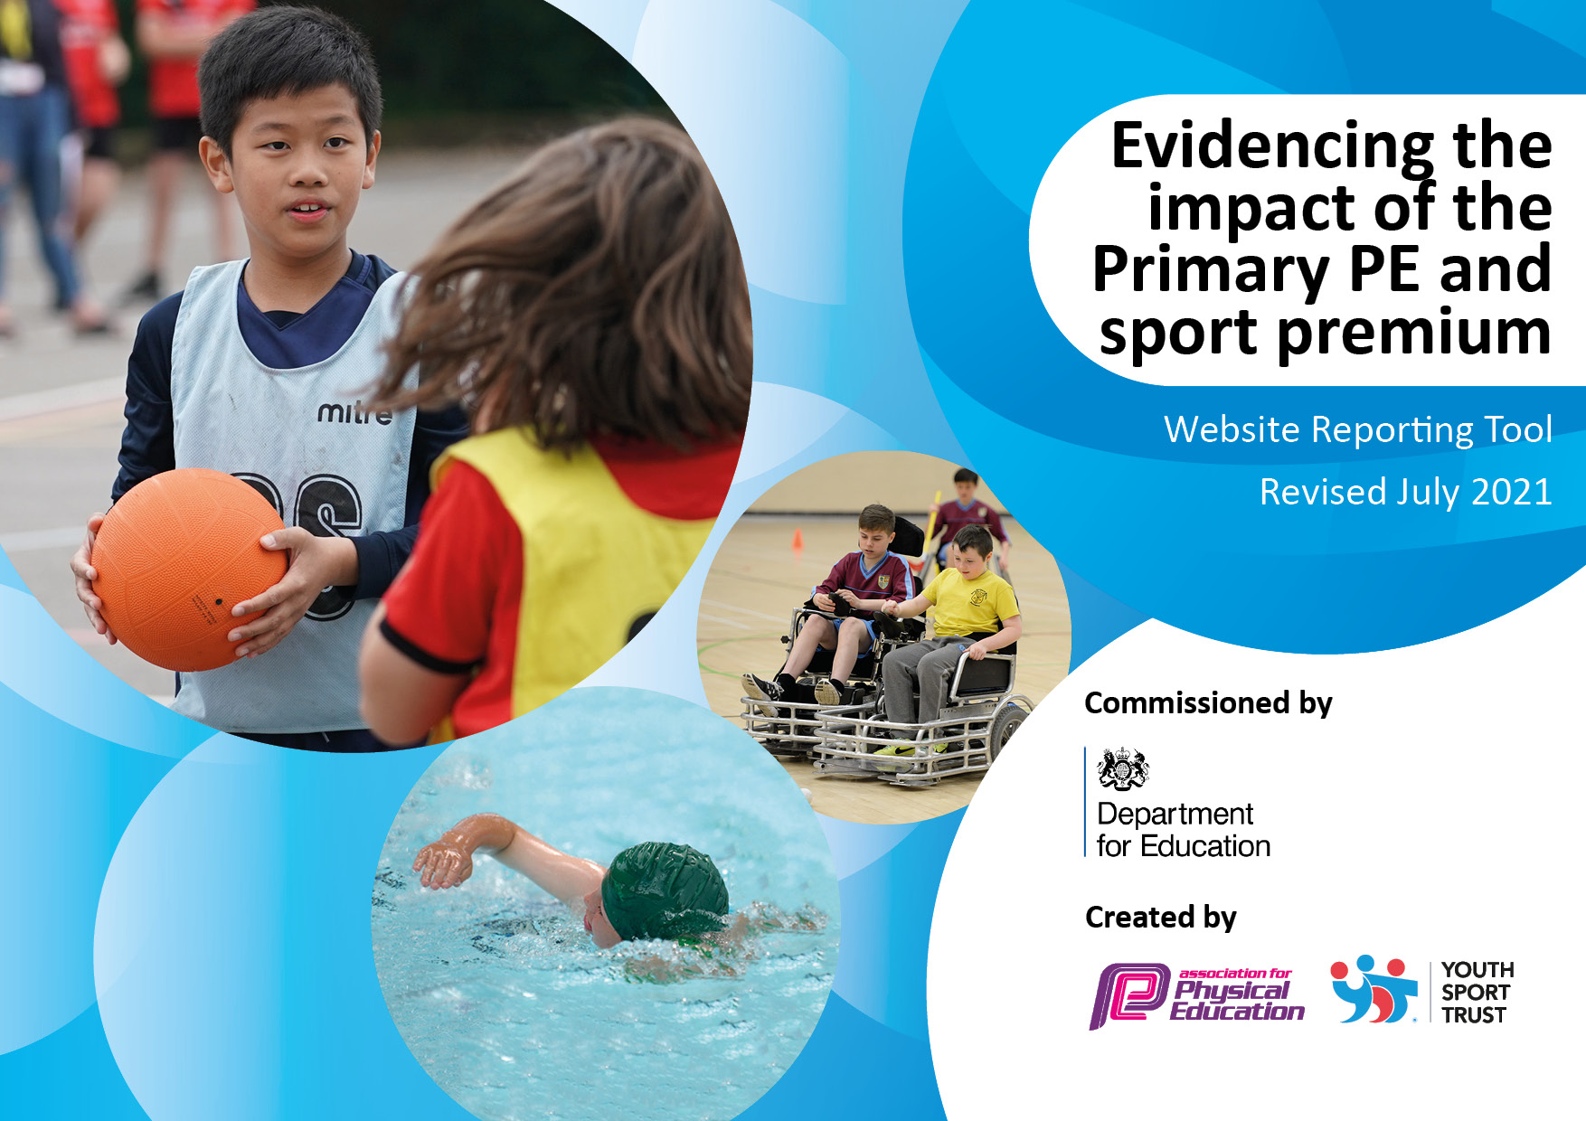
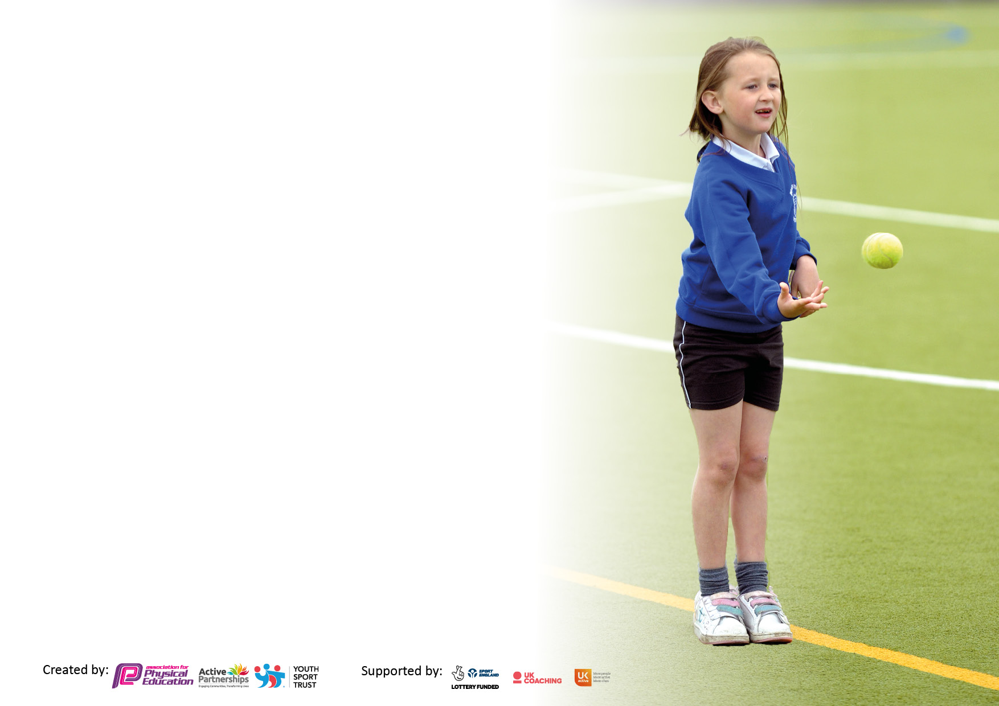

It is important that your grant is used effectively and based on school need. The Education Inspection Framework makes clear there will be a focus on ‘whether leaders and those responsible for governors all understand their respective roles and perform these in a way that enhances the effectiveness of the school’.

Under the Quality of Education Ofsted inspectors consider:
Intent - Curriculum design, coverage and appropriateness
Implementation - Curriculum delivery, Teaching (pedagogy) and Assessment
Impact - Attainment and progress

To assist schools with common transferable language this template has been developed to utilise the same three headings which should make your plans easily transferable between working documents.

Schools must use the funding to make additional and sustainable improvements to the quality of Physical Education, School Sport and Physical Activity (PESSPA) they offer. This means that you should use the Primary PE and sport premium to:

- Develop or add to the PESSPA activities that your school already offer
- Build capacity and capability within the school to ensure that improvements made now will benefit pupils joining the school in future years
- The Primary PE and sport premium should not be used to fund capital spend projects; the school’s budget should fund these.

Pleasevisitgov.ukfortherevisedDfEguidanceincludingthe5keyindicatorsacrosswhichschoolsshoulddemonstrate animprovement.Thisdocumentwillhelpyoutoreviewyourprovisionandtoreportyourspend.DfEencouragesschools to use this template as an effective way of meeting the reporting requirements of the Primary PE and sport premium.

We recommend you start by reflecting on the impact of current provision and reviewing the previous spend.

Schools are required to publish details of how they spend this funding, including any under-spend from 2019/2020, as well as on the impact it has on pupils’ PE and sport participation and attainment. All funding must be spent by 31st July 2022.

We recommend regularly updating the table and publishing it on your website throughout the year. This evidences your ongoing self-evaluation of how you are using the funding to secure maximum, sustainable impact. Final copy must be posted on your website by the end of the academic year and no later than the 31st July 2021. To see an example of how to complete the table please click HERE.
Created by: Supported by:

WWilliam Cassidi C. E. Aided Primary School
Details with regard to funding
Please complete the table below.

Total amount carried over from 2019/20 | £5,941
Total amount allocated for 2020/21 | £14,944
How much (if any) do you intend to carry over from this total fund into 2021/22? | £9,897
Total amount allocated for 2021/22 | £16,545
Total amount of funding for 2021/22. To be spent and reported on by 31st July 2022. | £27,454 (£1,021 utilised from 22.23)
Swimming Data
Please report on your Swimming Data below.

Meeting national curriculum requirements for swimming and water safety.  N.B. Complete this section to your best ability. For example you might have practised safe self-rescue techniques on dry land which you can then transfer to the pool when school swimming restarts.  Due to exceptional circumstances priority should be given to ensuring that pupils can perform safe self rescue even if they do not fully meet the first two requirements of the NC programme of study | 100%
What percentage of your current Year 6 cohort swim competently, confidently and proficiently over a distance of at least 25 metres?  N.B. Even though your pupils may swim in another year please report on their attainment on leaving primary school at the end of the summer term 2021.  Please see note above | 41%
What percentage of your current Year 6 cohort use a range of strokes effectively [for example, front crawl, backstroke and breaststroke]?  Please see note above | 53%
What percentage of your current Year 6 cohort perform safe self-rescue in different water-based situations? | 20%
Schools can choose to use the Primary PE and sport premium to provide additional provision for swimming but this must be for activity over and above the national curriculum requirements. Have you used it in this way? | Yes an additional session

Action Plan and Budget Tracking
Capture your intended annual spend against the 5 key indicators. Clarify the success criteria and evidence of impact that you intend to measure to evaluate for pupils today and for the future.

Academic Year: 2020/21 | Total fund allocated: | Date Updated:
Key indicator 1: The engagement of all pupils in regular physical activity – Chief Medical Officers guidelines recommend that primary school pupils undertake at least 30 minutes of physical activity a day in school |  |  |  | Percentage of total allocation:
 |  |  |  | 39%
Intent | Implementation |  | Impact
Your school focus should be clear what you want the pupils to know and be able to do and about  what they need to learn and to  consolidate through practice: | Make sure your actions to achieve are linked to your intentions: | Funding allocated: | Evidence of impact: what do pupils now know and what can they now do? What has changed?: | Sustainability and suggested next steps:
PE curriculum to develop transferable skills from the new whole school scheme: PE Planning.  Follow PE learning journeys on school website. | All children across all age ranges, PE activities relevant to age groups. | £ 3,500 | Pupils develop progression of transferable skills across the year groups. | They will develop skills during lessons which can be used at playtime and lunchtime and during various sporting activities
Encourage physical activity after school. Develop teamwork and social skills during after school:  Tennis  Badminton  Gymnastics  Football  No costing for parents/carers – poverty proofing access for all pupils  Pupils attend outdoor residential activity centre:  Outdoor learning  Team activities  Sporting activities: caving, rock climbing etc | Equipment for after school sports clubs  Coaching staff for sports clubs  All pupils able to participate in a residential experience, gaining confidence, working as a team and experiencing additional sporting activities not available in school or the local community. | £7,284 | All children can access sporting activities after school.  Lifelong activity promoted  Children who attend the clubs are signposted to opportunities at local clubs in the community.  Children gain in confidence and resilience.  Children are aware of a wider variety of sporting activities which they may undertake in the future. | All pupils attend trials at local town football club.  Organise ‘portable’ experiences at school ie archery within target games lessons.
Key indicator 2: The profile of PESSPA being raised across the school as a tool for whole school improvement |  |  |  | Percentage of total allocation:
 |  |  |  | 12%
Intent | Implementation |  | Impact
Your school focus should be clear what you want the pupils to know and be able to do and about  what they need to learn and to  consolidate through practice: | Make sure your actions to achieve are linked to your intentions: | Funding allocated: | Evidence of impact: what do pupils now know and what can they now do? What has changed?: | Sustainability and suggested next steps:
Increase opportunities for PESSPA by raising visibility, awareness and participation in activity by training Sports Leaders. | Purchase sports play equipment for use at playtime and lunchtime across school. | £3,274 | Y5/Y6 trained Sports Leaders are self-motivated to run Energise Clubs all year round.  Y6 Sports Leaders managed and promote use of the playtime/lunchtime equipment.  Y6 Leaders ran the R4L with a volunteer parent. They also led the Wake Up & Shake Up Dancing during Fun and Fitness Week. | Club was initially run with PE Lead teacher voluntary support during lunchtime. Later by the Sports Leaders themselves after support and training.  Next year Y6 leaders will run the R4L with support from another parent helper who was invited on site this year to support – this ensures continuity.
Awards certificates and stickers for Fun & Fitness week. | To reward and reinforce the importance of the School Sports Values. | £132 | Children receiving recognition for all of the School Games Values. | In the future, children nominate peers for School Games Values during PE lessons and sports clubs.

Key indicator 3: Increased confidence, knowledge and skills of all staff in teaching PE and sport |  |  |  | Percentage of total allocation:
 |  |  |  | 3%
Intent | Implementation |  | Impact
Your school focus should be clear | Make sure your actions to | Funding | Evidence of impact: what do | Sustainability and suggested
what you want the pupils to know | achieve are linked to your | allocated: | pupils now know and what | next steps:
and be able to do and about | intentions: |  | can they now do? What has
what they need to learn and to |  |  | changed? :
consolidate through practice:
Provide subject specialist coaches:  rugby, judo and cricket. | Members of staff observe and assist in sessions. This increases ability, confidence and ideas to deliver coaching sessions themselves. | £840 | Pupils have gained transferable skills during the rugby, judo and cricket sessions. | Class teacher was able to deliver rugby games sessions during Fun & Fitness week across all the age ranges.  Coaches required again next year due to staffing changes in UKS2.
Key indicator 4: Broader experience of a range of sports and activities offered to all pupils |  |  |  | Percentage of total allocation:
 |  |  |  | 43%
Intent | Implementation |  | Impact
Your school focus should be clear | Make sure your actions to | Funding | Evidence of impact: what do | Sustainability and suggested
what you want the pupils to know | achieve are linked to your | allocated: | pupils now know and what | next steps:
and be able to do and about | intentions: |  | can they now do? What has
what they need to learn and to |  |  | changed?:
consolidate through practice:
Additional swimming sessions purchased to enable children to consolidate skills especially after COVID-19 when lessons were cancelled.  Additional achievements: Frisbee, judo, Mindful Minis (yoga and mindfulness), golf, hula hooping, archery and basketball from the Teesside Lions Club. | Children in Year 3 undertake usual funded activities. Additional sessions organised for Years 4, 5 and 6 to develop and consolidate swimming and life-saving skills.  All children from N-Y6 given the opportunity to participate in expert coaching sessions.  Purchase of additional resources to enable activities to be continued within school. | £7,640  £4,059 | Refer to Year 6 swimming results on page 1. All pupils attained confidence in water and water safety certificates. All pupils able to swim 5m. Life skill achieved.  Lifelong impact – each child finds a sport/activity which they can participate in.  Pupils now have a wider set of skills and knowledge after the sessions. | Additional session to be undertaken during 22/23 academic year to enable consolidation of skills.  Staff now have a wider skill set and collection of ideas in a selection of sports after observing and assisting during the sessions. Children have been signposted to local clubs: Teesside Lions. Judo and Stockton Football Club.  Equipment purchased to enable the continuation of these sports:  Basketball posts  Tennis net  Archery sets  Frisbee targets.

Key indicator 5: Increased participation in competitive sport |  |  |  | Percentage of total allocation:
 |  |  |  | 3%
Intent | Implementation |  | Impact
Your school focus should be clear | Make sure your actions to | Funding | Evidence of impact: what do | Sustainability and suggested
what you want the pupils to know | achieve are linked to your | allocated: | pupils now know and what | next steps:
and be able to do and about | intentions: |  | can they now do? What has
what they need to learn and to |  |  | changed?:
consolidate through practice:
Build up participation in competitive events again. Attend competitions including: football, rugby, KS2 Cross Country and KS2 Athletics events. | Children to be given the opportunity to compete against other schools in the Central Cluster and the Tees Valley Area at no cost to the children as part of our commitment to poverty proofing access for all. | £725 | All pupils now have the experience of competing at cluster level against other schools in a large sports arena with spectators.  Children qualified for finals in both events. | Signpost those with success at competitive events to local specialist clubs for athletics and running.

Signed off by
Head Teacher: | Mrs. J. Cornelius
Date: | 17.7.2022
Subject Leader: | Mrs J Lister
Date: | 15.7.22
Governor: | Mrs. S. Bell
Date: | 18.7.2022

