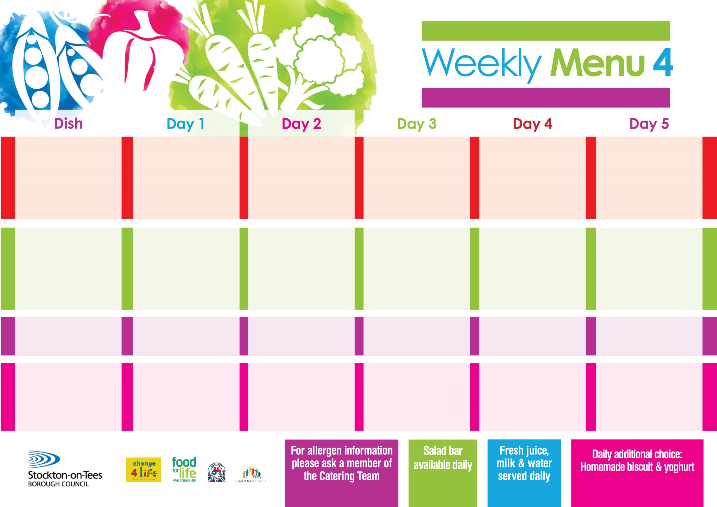

**24th January, 28th February & 28th March, 2022**

**Minced Beef Pie**

**Cheese Omelette (V)**

**Sliced Roast Ham**

**Variety of Sandwiches & Wraps:-**

**Cheese (V), Tuna & Egg (V)**

**Homemade Quiche**

**Oven Baked Jacket Potatoes**

**Creamed Potatoes**

**Garden Peas**

**Baked Beans**

**Bakewell Tart**

**with Custard Sauce**

**Cold Bar**

**Melon Boat**

**Beef Burger in a Bun**

**or**

**Quorn Burger in a Bun (V)**

**Fish Fillet Fingers**

**Sliced Roast Turkey**

**Variety of Sandwiches & Wraps:-**

**Cheese (V), Tuna & Egg (V)**

**Homemade Quiche**

**Oven Roasted Potatoes**

**Boiled Potatoes**

**Sweetcorn**

**Spaghetti Hoops**

**Creamy Rice Pudding**

**with Jam Sauce**

**Cold Bar**

**Watermelon Slices**

**Chicken Cobbler**

**or**

**Baked Quorn Sausages (V)**

**Baked Sausages**

**Sliced Roast Chicken**

**Variety of Sandwiches & Wraps:-**

**Cheese (V), Tuna & Egg (V)**

**Homemade Quiche**

**Oven Baked Potato Wedges**

**Creamed Potatoes**

**Cauliflower & Swede**

**Spaghetti Hoops**

**Eve’s Pudding**

**with Custard Sauce**

**Cold Bar**

**Fresh Fruit Salad**

**Fish Goujons**

**Cheese & Tomato Pizza (V)**

**Sliced Roast Ham**

**Variety of Sandwiches & Wraps:-**

**Cheese (V), Tuna & Egg (V)**

**Homemade Quiche**

**Oven Baked Chips**

**Garden Peas**

**Baked Beans**

**Chocolate & Lime Sponge**

**with Custard Sauce**

**Cold Bar**

**Fresh Fruit Kebab**

**Pork & Carrot Meatballs in Rich Onion Gravy**

**Jacket Potato filled with**

**Tuna, Cheese (V)**

**or Baked Beans (V)**

**Sliced Roast Ham**

**Variety of Sandwiches & Wraps:-**

**Cheese (V), Tuna & Egg (V)**

**Homemade Quiche**

**Creamed Potatoes**

**Baked Jacket Potatoes**

**Broccoli & Diced Carrots**

**Baked Beans**

**Creamy Rice Pudding**

**with Jam Sauce**

**Cold Bar**

**Fresh Fruit Bowl**

**Primary School Menus**

**Traditional Fayre**

**Cold Selection**

**Potatoes & Vegetables**

**Desserts**