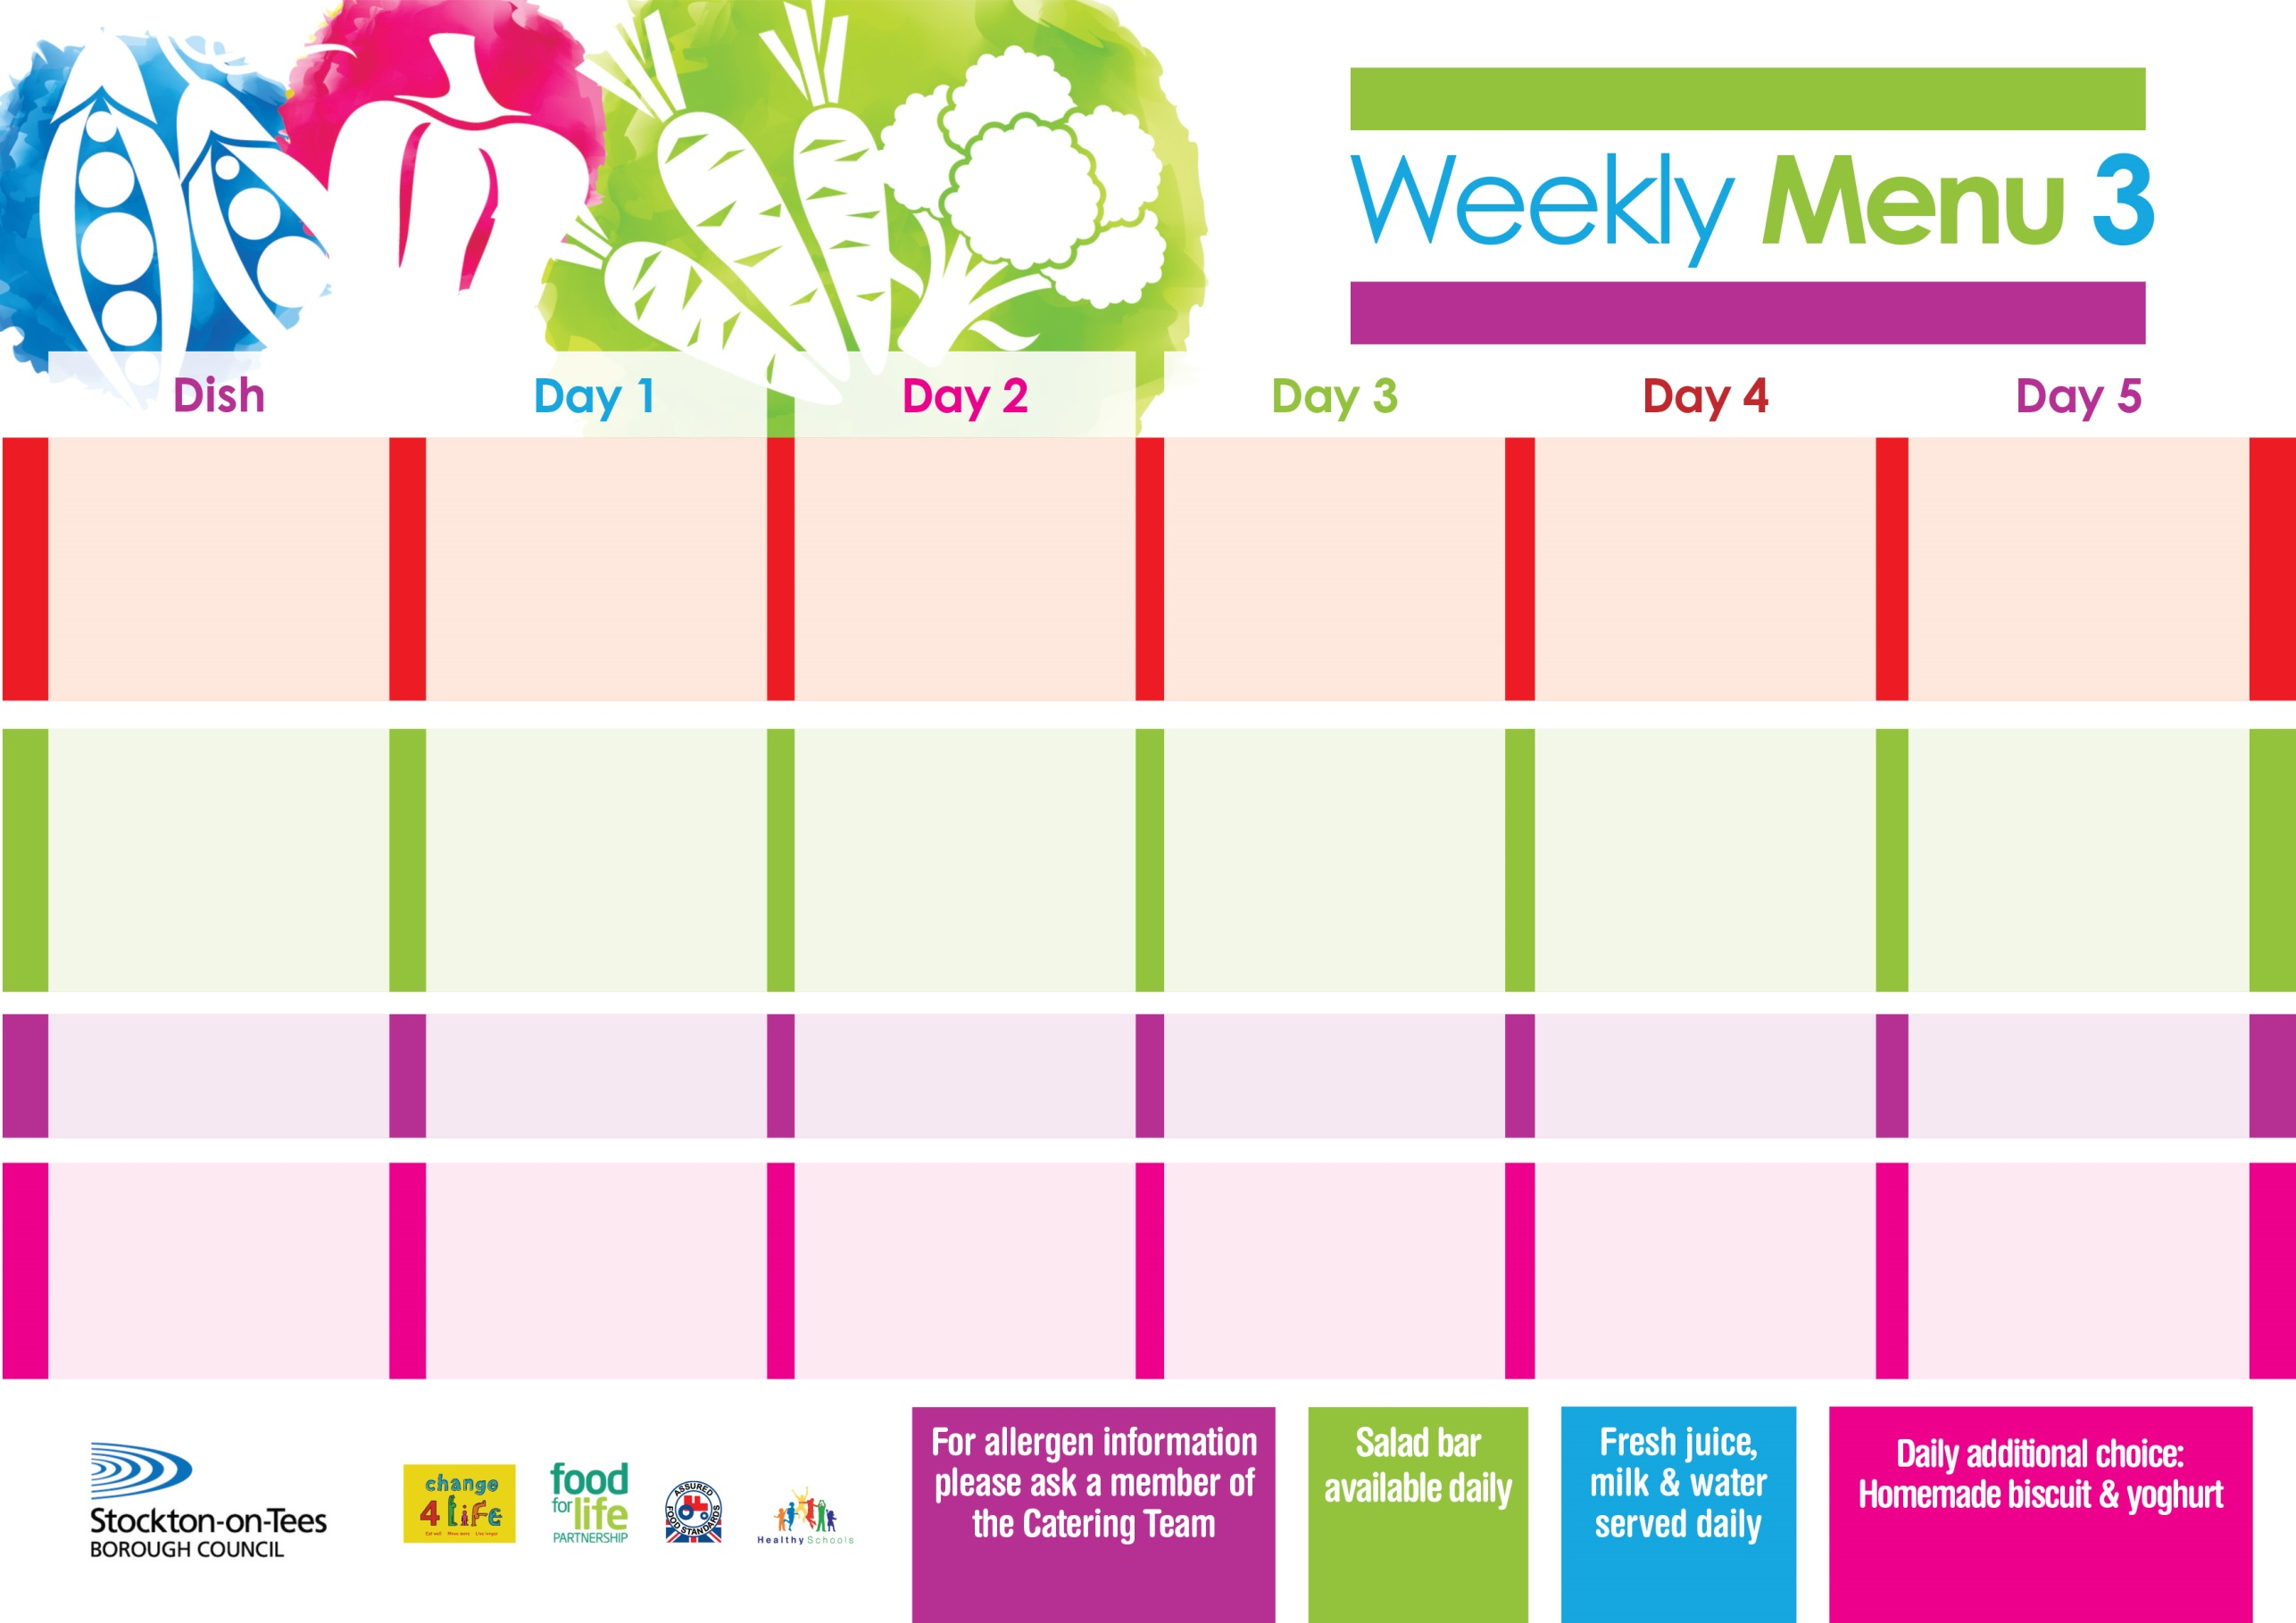

**17th January, 14th February & 21st March, 2022**

**Roast Beef &**

**Yorkshire Puddings**

**Cheese & Onion Pasty (V)**

**Sliced Roast Ham**

**Variety of Sandwiches & Wraps:-**

**Cheese (V), Tuna & Egg (V)**

**Homemade Quiche**

**Creamed Potatoes**

**Oven Roasted Potatoes**

**Broccoli**

**Diced Carrots**

**Festival Shortcake**

**with Custard Sauce**

**Cold Bar**

**Fresh Fruit Bowl**

**Jacket Potatoes filled with Tuna, Cheese**

**Pizza (V)**

**Sliced Roast Chicken**

**Variety of Sandwiches & Wraps:-**

**Cheese (V), Tuna & Egg (V)**

**Homemade Quiche**

**Rice**

**Oven Baked Potato Wedges**

**Mixed Vegetables**

**Spaghetti Hoops**

**Apple & Rhubarb Pie**

**with Custard Sauce**

**Cold Bar**

**Fresh Fruit Bowl**

**Chicken & Vegetables with Puff Pastry Lid**

**or**

**Diced Quorn with Vegetables with Puff Pastry Lid (V)**

**Fish Cake in Natural Crumb**

**Sliced Roast Ham**

**Variety of Sandwiches & Wraps:-**

**Cheese (V), Tuna & Egg (V)**

**Homemade Quiche**

**Creamed Potatoes**

**Oven Roasted Potatoes**

**Cauliflower/Cabbage**

**Baked Beans**

**Creamy Rice Pudding**

**with Peaches**

**Cold Bar**

**Melon Boat**

**Tempura Battered Fish Fillet**

**Pizza Whirls (V) or Baked Beans (V)**

**Sliced Roast Turkey**

**Variety of Sandwiches & Wraps:-**

**Cheese (V), Tuna & Egg (V)**

**Homemade Quiche**

**Oven Baked Chips**

**Garden Peas**

**Baked Beans**

**Ginger Sponge**

**with Custard Sauce**

**Cold Bar**

**Fresh Fruit Salad**

**Spaghetti Bolognaise**

**Quorn Bolognaise (V)**

**Sausage Roll**

**Sliced Roast Ham**

**Variety of Sandwiches & Wraps:-**

**Cheese (V), Tuna & Egg (V)**

**Homemade Quiche**

**Homemade Garlic Bread**

**Oven Roasted Potatoes**

**Garden Peas**

**Sweetcorn**

**Pineapple Upside Down Cake**

**with Custard Sauce**

**Cold Bar**

**Fresh Fruit Kebab**

**Primary School Menus**

**Traditional Fayre**

**Cold Selection**

**Potatoes & Vegetables**

**Desserts**