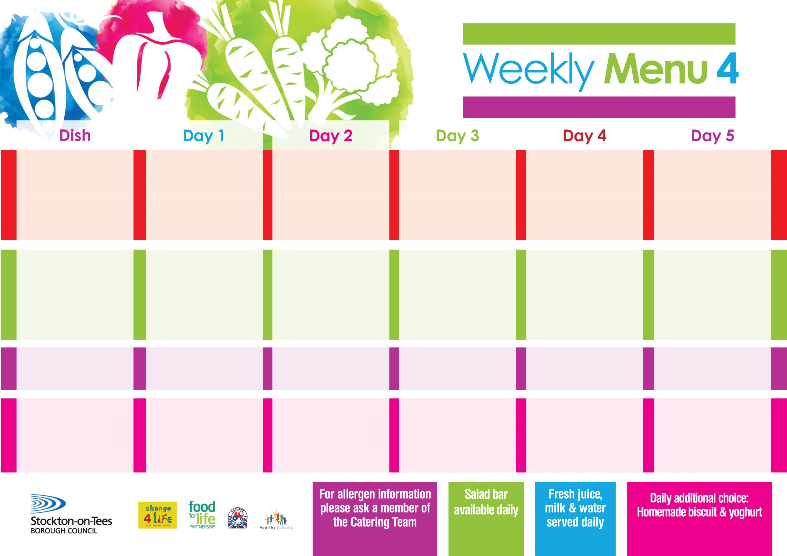

**22nd January, 26th February & 25th March, 2024**

**Baked Cumberland Sausage**

**Creamed Potatoes**

**Cabbage**

**Cauliflower**

**Baked Quorn Sausage (V)**

**Jacket Potato filled with**

**Tuna, Cheese (V) or**

**Baked Beans (V)**

**Variety of Sandwiches**

**Cheese (V), Tuna & Egg (V)**

**Jam Sponge**

**with Custard Sauce**

**Cold Bar**

**Fresh Fruit**

**Roast Beef served with Yorkshire Puddings**

**Creamed Potatoes**

**Diced Carrots**

**Broccoli**

**Fish Fillet Stars**

**Creamed Potatoes**

**Diced Carrots**

**Broccoli**

**Variety of Sandwiches**

**Cheese (V), Tuna & Egg (V)**

**Orange Sponge**

**with Custard Sauce**

**Cold Bar**

**Fresh Fruit**

**Chicken Curry**

**served with Rice**

**Mixed Vegetables**

**Quorn Curry & Rice (V)**

**Sausage Roll**

**Baked Potato Wedges**

**Spaghetti Hoops**

**Variety of Sandwiches**

**Cheese (V), Tuna & Egg (V)**

**Chocolate Lime Cake**

**with Custard Sauce**

**Cold Bar**

**Fresh Fruit**

**Harry Ramsden Fish Fillet**

**Oven Baked Chips**

**Baked Beans**

**Garden Peas**

**Pizza (V)**

**Oven Baked Chips**

**Baked Beans**

**Garden Peas**

**Variety of Sandwiches**

**Cheese (V), Tuna & Egg (V)**

**Homemade Quiche**

**Bakewell Tart**

**with Custard Sauce**

**Cold Bar**

**Fresh Fruit**

**Cheese & Tomato Pizza (V)**

**Oven Roasted Potatoes**

**Baked Beans**

**Sweetcorn**

**Penne Pasta in Tomato Sauce (V)**

**Homemade Garlic Bread**

**Sweetcorn**

**Variety of Sandwiches**

**Cheese (V), Tuna & Egg (V)**

**Creamy Rice Pudding**

**with Jam Sauce**

**Cold Bar**

**Fresh Fruit**

**Primary School Menus**

**Traditional Fayre**

**Cold Selection**

**Desserts**