[](http://www.nhsdirect.nhs.uk/index.aspx)

**William Cassidi C. E. Aided primary School**

**Oral Health Policy**

**Approved: 19th May 2021**

**Review Date: May 2022**

**Oral Health Policy**

**William Cassidi C.E. Aided Primary School suspended the Oral Health programme during the COVID-19 pandemic from March 2020 onwards. This decision was supported by members of the Curriculum Committee when the Oral Health Policy was reviewed in May 2020. A new review date of May 2021 was agreed.**

**William Cassidi C.E. Aided Primary School continues to support the promotion of good oral health and will resume the programme no earlier than September 2021 should the pandemic be ended and following a robust risk assessment of the programme. The programme must be judged to be a sufficiently low risk for the programme to be resumed. William Cassidi reserves the right to continue the suspension the programme if necessary throughout the academic year 2021-2022.The policy will be reviewed May 2022.**

William Cassidi C. E. Primary School’s oral health policy sets out the schools formal commitment to providing a high standard of oral health promotion, linking this to education and life skills to promote optimum health in all of our students.

The Governors aim to ensure that all aspects of oral health promotion at William Cassidi C. E. Primary School promotes the health and wellbeing of pupils, staff and visitors to our school, supporting individual needs (cultural, ethical and medical) as appropriate.

The Governors will ensure the creation of partnerships between staff; pupils, parents and other relevant groups so that all those involved in oral health at William Cassidi C. E. Primary School have the opportunity to plan, implement deliver and evaluate oral health promotion programmes.

William Cassidi C. E. Primary School is committed to

* Supporting partnerships with agencies which support Oral Health and deliver effective oral health promotion involving staff, parents and pupils.
* Planning and delivering effective oral health promotion through participating in local initiatives as determined by Public Health England (PHE).
* Raising concerns relating to oral health of pupils in line with our safeguarding policy.

By implementing our oral health policy there will be a formal structure in place to allow feedback from students, staff and parents and we are committed to responding appropriately to such feedback. This will ensure that we continue to rate oral health very highly as demonstrated by the high standard set by our local Tees Community Dental Service Oral Health Promotion Department. We will link oral health to what is taught in the curriculum to ensure students receive consistent and up to date messages around oral hygiene and healthy eating. The school oral health policy will be linked to the nutrition and food policy which relates to the Government school food regulations, to Every Child Matters agenda and to the National Healthy Schools Programme.

William Cassidi C. E. Primary School named Oral health lead is the PSHE lead.

**Tooth Brushing**

A daily supervised tooth brushing programme is a local initiative to help improve the oral health of children in Teesside. William Cassidi C. E. Primary Schoolhas been identified to deliver tooth brushing in Nursery, Reception and Year 1. Tooth brushing resources are provided by Tees Community Dental Service Oral Health Promotion Department subject to funding and consist of storage racks, toothbrushes and toothpaste. We encourage students to brush their teeth at home and in the education setting. We do this with the support of the school staff and reinforcing messages to parents at home.

William Cassidi C. E. Primary School is committed to:

* Delivering the tooth brushing scheme in line with the guidance provided by the Tees Community Dental Service Oral Health Promotion Department.
* Implementing a high stand of cross infection control in line with the guidance provided by the Tees Community Dental Service, Oral Health Promotion Department and the local authority infection control policies.
* Encouraging all students to participate in the scheme at school and at home.
* Maintaining a high standard of staff knowledge base in Oral Health Promotion.

**Guidance on Tooth Brushing in School:**

* The school will have a nominated oral health lead person responsible for liaising with the Oral Health Promotion Department, and ensuring the effective delivery of the scheme in school.
* Staff involved in the tooth brushing scheme will be suitably trained, which will be recorded and monitored.
* All parents will be made aware of the scheme via consent letter.
* Tooth brushing will take place in a suitable environment in line with cross infection control.
* All children are supervised whilst brushing.
* Toothbrushes will be rinsed individually after each session by the child/member of staff.
* Storage racks will be maintained, and cleaned on a regular basis inline with infection control.
* Every child with have their own identifiable toothbrush. (see appendix C)
* A fluoride toothpaste will be used which contains the current recommended level of Fluoride.
* Every child will use toothpaste which has been dispensed in accordance with cross infection control guidance. (see appendix D)
* A pea sized amount of fluoride toothpaste will be dispensed for all children over the age of 3yrs . (see appendix C)
* Children will be encouraged to spit out excess toothpaste into a tissue
* Toothbrushes will be replaced every three months or sooner if required, when bristles become splayed, are dropped on the floor or used by a pupil with a contagious infection. (see appendix E)
* Staff will wash hands before and after each brushing session.
* Toothbrushes will be stored in an upright position, out of reach of children, away from toileting facilities and left to air dry when not in use.
* Storage equipment will be washed weekly, and replaced if cracked, scratched or rough surfaces appear.

Appendix A sets out specific tooth brushing routines in William Cassidi C. E. Primary School.

**Healthy Eating**

**School Meals:**

Food served in schools and academies in England must meet the school food standards so that children have healthy, balanced diets. These standards are intended to help children develop healthy eating habits and ensure they get the energy and nutrition they need across the school day.

A child’s healthy, balanced diet should consist of

* Plenty of fruit and vegetables.
* Plenty of unrefined starchy foods.
* Some meat, fish, eggs beans and other non-dairy sources of protein.
* Some milk and dairy foods.
* A small amount of food and drink high in fat, sugar and / or salt.

**School food other than lunch**

Oral health is affected by the frequent consumption of food or drinks that contain extrinsic sugars. *[School Name]* recognises the importance of reducing the frequency of sugary food / drinks that are available in school to tackle tooth decay and to comply with The Requirements for School Food Regulations 2014.

*{available at* [*http://www.legislation.gov.uk/id/uksi/2014/1603*](http://www.legislation.gov.uk/id/uksi/2014/1603)*)*

*}*

William Cassidi C. E. Primary School is committed to

* Providing free, fresh drinking water which is available at all times.
* Providing lower fat milk which will be available at least once a day.
* Providing other low fat/low sugar drinks as part of a meal only.
* Providing fresh whole fruit as a snack in between meals (on occasion dried fruit may be provided by the free fruit scheme after school holiday periods).
* Not giving sweets as rewards.
* Not allowing cakes to be consumed in school (this does not apply at parties, celebrations to mark religious or cultural occasions, or at fund raising events)
* Sending home any confectionary that is brought into school.

Healthy snack guide Appendix B

**Dental Emergencies**

**Knocked – out tooth:**

On occasions children may injure themselves affecting the mouth. If an adult tooth is knocked out the sooner it is re-implanted, the more likely it is to embed itself back into the gum. If a child has sustained a facial injury this will be assessed by the first aider in school. Who will follow the advice given by NHS choices as below:

This is for adult teeth only; **children’s baby teeth should not be implanted**.

* The tooth should be handled by the top white part (the crown) and avoid touching the root.
* Do not scrape or brush the tooth.
* If the tooth is dirty, it should be rinsed with milk or a saline (salt water) solution and placed back into its socket in the mouth as soon as possible. The tooth should not be rinsed with water or alcohol.
* When the tooth is back in its socket, ask the child to bite down onto a clean piece of material (such as a handkerchief) or a wet tea bag to keep it in place.
* If the tooth cannot be re implanted it should be held between the cheek and gum until the child can manage to see a dentist, or store the tooth in a clean container and cover it with milk or a small amount of saliva.

Chipped or broken teeth should be reported to parents / guardians in line with the school accident policy where non emergency appointments can be made.

Parent / guardians should be informed immediately so that a dental appointment can be made.

In the event that the pupil does not have a dentist, the Teesside Dental Helpline can be called for information on local dental practices. 0345 045 0620 or text 07700 380000.

**Oral Health Education**

Providing the children with a sound knowledge in oral health is a priority at William Cassidi C. E. Primary Schoolwe strive to provide a holistic approach to health whereby dental health is given equal priority to general health messages.

William Cassidi C. E. Primary Schoolis committed to

* Providing parents with relevant information / literature relating to oral health.
* Working in partnership with dental professionals.
* Providing dental health education to all pupils.
* Incorporating dental health education into the curriculum
* Utilizing resources available to loan from the Oral Health Promotion Department.

Further guidance on oral health can be obtained from

Tees Community Dental Service

Oral Health Promotion Department

01642 383833

**Appendix A**

|  |  |
| --- | --- |
| **Year groups taking part in scheme** | |
| **Year** | **Brushing** |
| 2ys | **N/A** |
| Nursery | **✓** |
| Rec | **✓** |
| Y1 | **✓** |
| Y2 | **x** |
| Y3 | **x** |
| Y4 | **x** |
| Y5 | **x** |
| Y6 | **x** |

|  |  |  |  |  |  |
| --- | --- | --- | --- | --- | --- |
| **Class** | **Type of Rack**  (Toy Rack/BrushBus)  Type of Toothbrush  (Toy/Healthy Snacks/Sports) | **Storage Area**  (Up high) | **Tooth Brushing Area**  (Where?) | **Cleaning Procedure:**  Of area (product used)  Of Rack:  Of Tooth brushes: | **Method of brushing:**  One tube of toothpaste dispensed onto?  Each child every day?  Rotational brushing – how long? |
| **2yrs** |  |  |  |  |  |
| **Nursery** | x | x | x | x | Plate/sheet  Each day  As directed by song |
| **Reception** | x | x | x | x | As above |
| **Year 1** | x | x | x | x | As above |
| **Year 2** |  |  |  |  |  |
| **Year 3** |  |  |  |  |  |
| **Year 4** |  |  |  |  |  |
| **Year 5** |  |  |  |  |  |
| **Year 6** |  |  |  |  |  |

***Oral Health Snack Guidance***

***Meal Times Only - these snacks should only be eaten occasionally and as part of a meal***

Foods

* Sweets and chocolate
* Dried fruit e.g. raisins, apricots
* Tinned fruit - in natural juice or syrup
* Biscuits, cakes
* Fruit scones, teacakes
* Crisps
* Ice Cream
* Fruit yoghurts
* Sandwiches with sweet fillings e.g. jam
* Fruit yoghurt
* Sweet popcorn e.g. toffee or caramel

Drinks

* Fresh fruit juice
* Diluted cordial juices
* Fizzy drinks
* Milkshakes
* Flavoured or carbonated water
* Fruit smoothies
* Hot chocolate

***Between Meals - healthy snacks between meals should be encouraged to cut down on the frequency of sugars***

Foods

* Fresh fruit and vegetables
* Salads including pasta, wholegrain rice and couscous (Occasionally)
* Hard boiled egg
* Small portions of Cheese *(not exceeding 30g in 1 day),*
* Cream cheese or cottage cheese
* Hummus
* Bread or toast - including white, wholemeal, granary, brown, wheatgerm, multigrain, potato bread, chapattis, plain baked naan, rotis, rolls, bagels, pitta and wraps.
* Sandwiches with savoury fillings e.g. lean meat or fish, cheese, egg, salad
* Savoury scones (try making wholemeal)
* Plain popcorn
* Plain yoghurt
* Nuts and seeds

Drinks

• Plain milk

• Plain water

• Tea/coffee (without sugar)



**Appendix B**

|  |  |  |  |  |
| --- | --- | --- | --- | --- |
|  | **Rack Colour** | |  |  |
|  | **Toys** |  | **Name** | **Date** |
|  |  | **House** |  |  |
|  |  | **Apple** |  |  |
|  |  | **Bike** |  |  |
|  |  | **Bus** |  |  |
|  |  | **Chair** |  |  |
|  |  | **Tree** |  |  |
|  |  | **Coat** |  |  |
|  |  | **Hat** |  |  |
|  |  | **Pram** |  |  |
|  |  | **Shoe** |  |  |
|  |  | **Flower** |  |  |
|  |  | **Bed** |  |  |
|  |  | **Teddy** |  |  |
|  |  | **Bricks** |  |  |
|  |  | **Cup** |  |  |
|  |  | **Spoon** |  |  |
|  |  | **Ball** |  |  |
|  |  | **Car** |  |  |
|  |  | **Book** |  |  |
|  |  | **Pencil** |  |  |

**Appendix C**



**Appendix D**

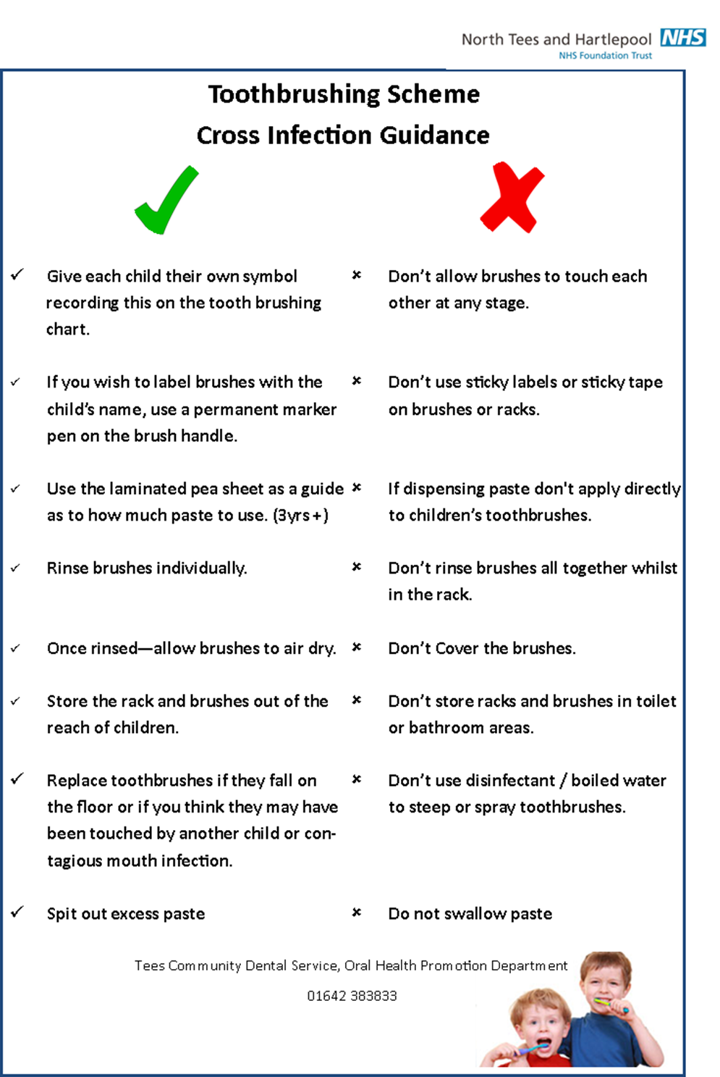

**Appendix E**