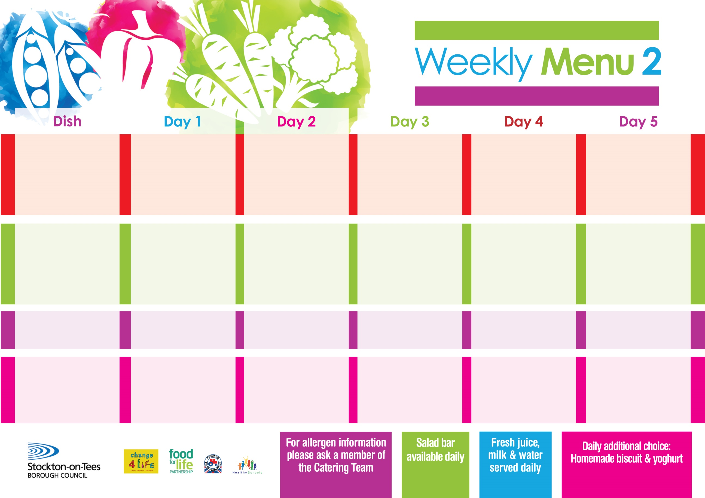

**10th January, 7th February & 14th March, 2022**

**Roast Gammon served with Pineapple**

**Cheese & Onion Rolls (V)**

**Sliced Roast Chicken**

**Variety of Sandwiches & Wraps:-**

**Cheese (V), Tuna & Egg (V)**

**Homemade Quiche**

**Baby Boiled Potatoes**

**Oven Roasted Potatoes**

**Green Beans & Cauliflower**

**Spaghetti Hoops**

**Chocolate Crunch**

**with Custard Sauce**

**Cold Bar**

**Fresh Fruit Bowl**

**Lasagne**

**or**

**Quorn Lasagne (V)**

**Fish Stars**

**Sliced Roast Ham**

**Variety of Sandwiches & Wraps:-**

**Cheese (V), Tuna & Egg (V)**

**Homemade Quiche**

**Baked Potato Wedges**

**Homemade Garlic Bread**

**Spaghetti Hoops**

**Tossed Salad**

**Choc Chip Sponge**

**with Custard Sauce**

**Cold Bar**

**Fresh Fruit Salad**

**Steak Pie**

**Jacket Potato filled with**

**Tuna, Cheese (V)**

**or Baked Beans (V)**

**Sliced Roast Ham**

**Variety of Sandwiches & Wraps:-**

**Cheese (V), Tuna &**

**Corned Beef**

**Homemade Quiche**

**Creamed Potatoes**

**Oven Baked Jacket Potatoes**

**Baked Beans**

**Mixed Vegetables**

**Jam Roly Poly**

**with Custard Sauce**

**Cold Bar**

**Fresh Fruit Platter**

**Breaded Chicken Breast**

**Macaroni Cheese (V)**

**Sliced Roast Ham**

**Variety of Sandwiches & Wraps:-**

**Cheese (V), Tuna & Egg (V)**

**Homemade Quiche**

**Oven Roasted Potatoes**

**Homemade Herby Bread**

**Garden Peas**

**Sweetcorn**

**Cornflake Tart**

**with Custard Sauce**

**Cold Bar**

**Watermelon Slices**

**Fish Goujons**

**Cheese pizza (V)**

**Sliced Roast Ham**

**Variety of Sandwiches & Wraps:-**

**Cheese (V), Tuna & Egg (V)**

**Homemade Quiche**

**Oven Baked Chips**

**Garden Peas**

**Baked Beans**

**Lemon Sponge**

**with custard Sauce**

**Cold Bar**

**Melon Boat**

**Primary School Menus**

**Traditional Fayre**

**Cold Selection**

**Potatoes & Vegetables**

**Desserts**