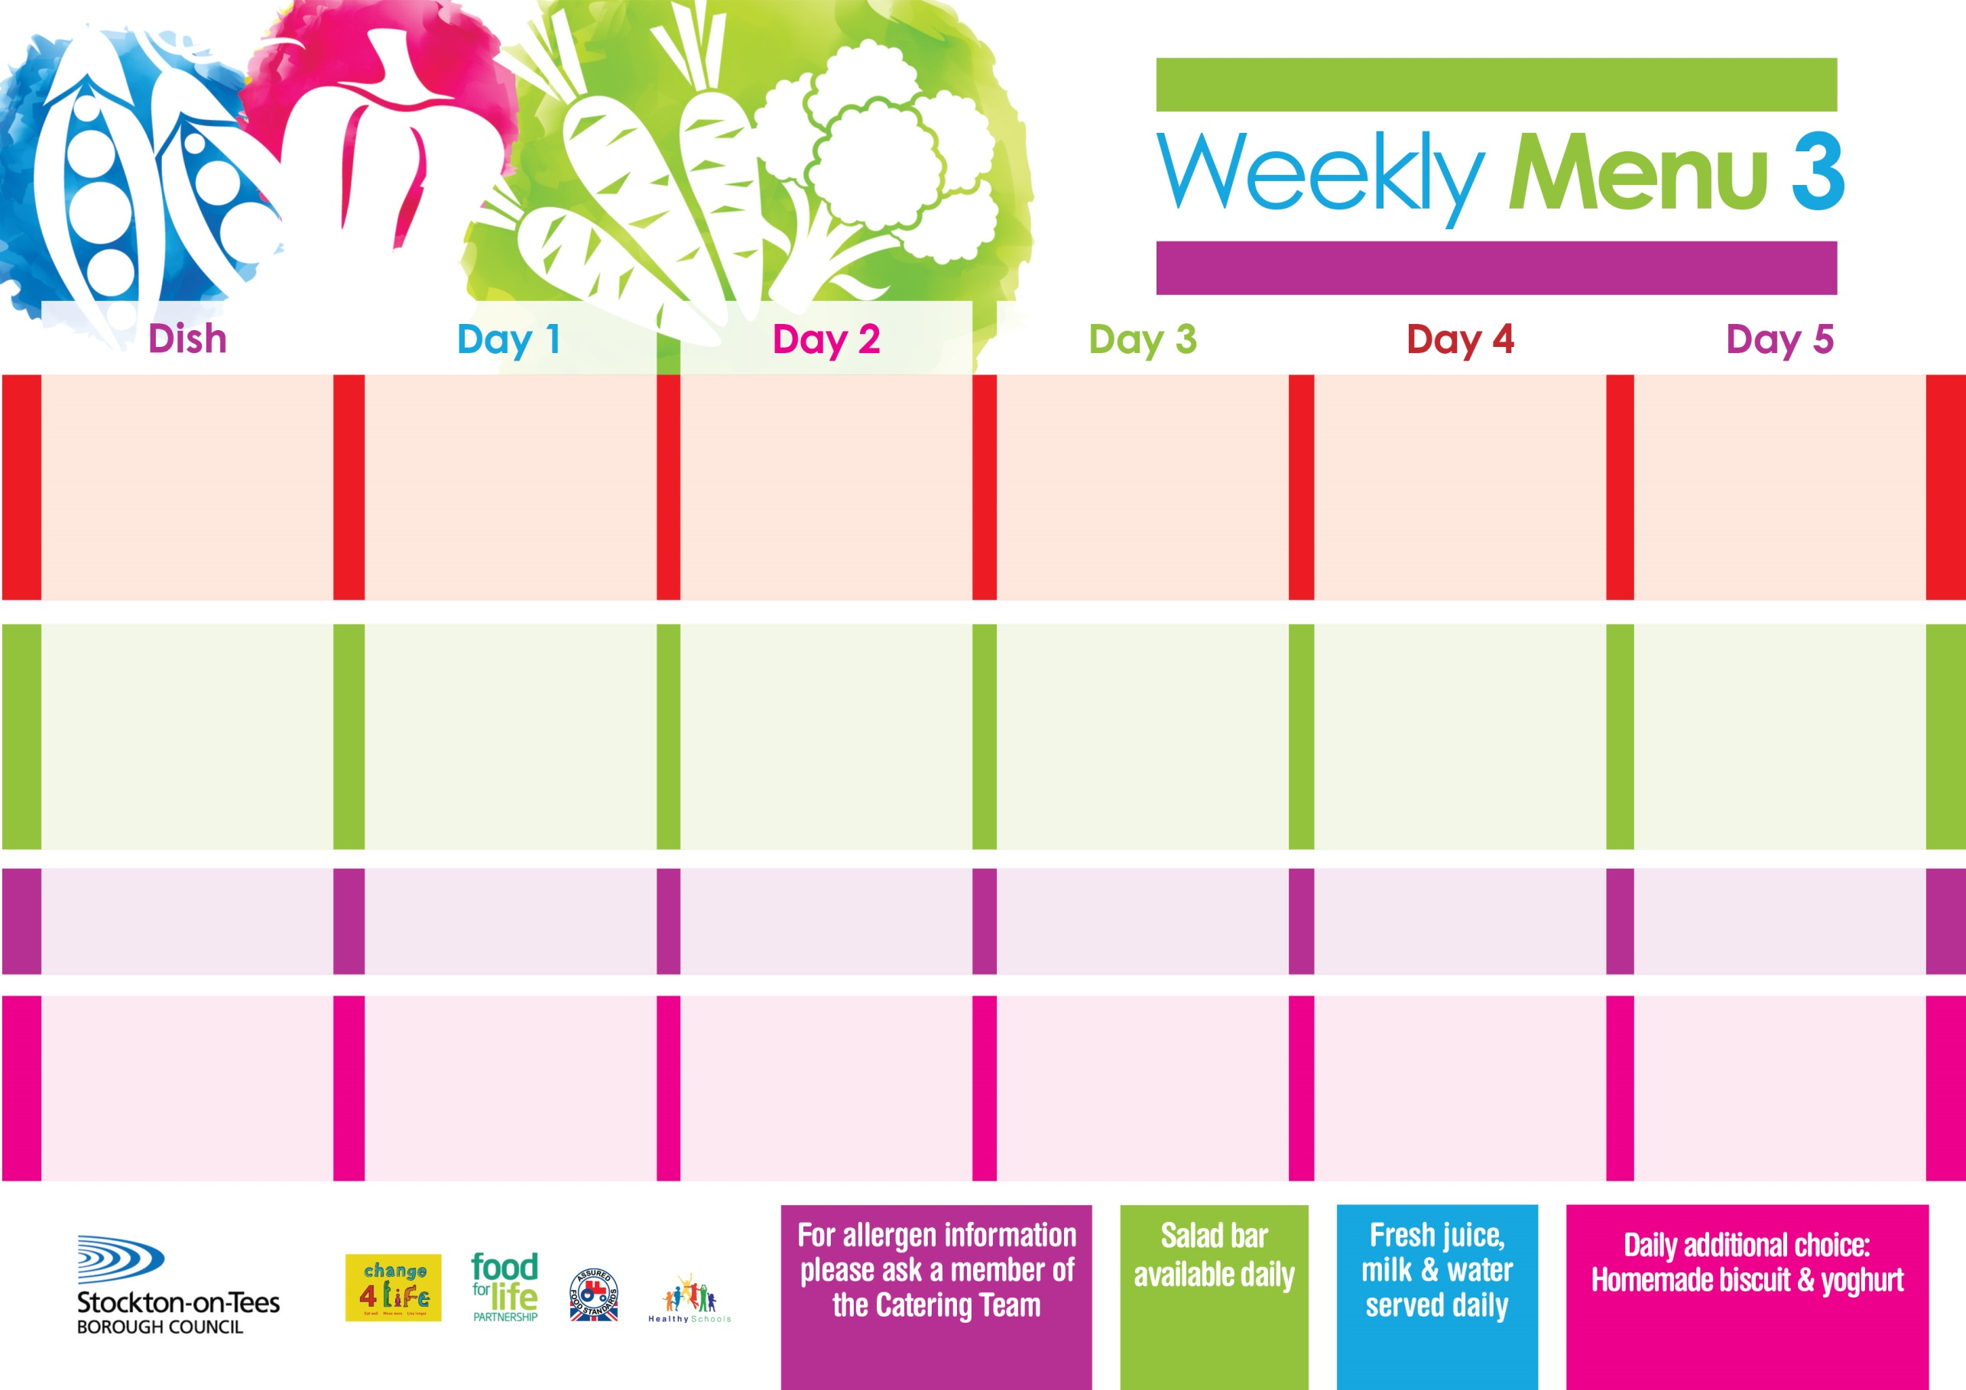

**9th May, 13th June & 11th July, 2022**

**Lasagne**

**Homemade Garlic Bread**

**Tossed Salad**

**Jacket Potato filled with Tuna, Cheese (V) or Baked Beans (V)**

**Variety of Sandwiches**

**Cheese (V), Tuna & Egg (V)**

**Homemade Quiche**

**Syrup Roly Poly**

**with Custard Sauce**

**Cold Bar**

**Fresh Fruit Bowl**

**Mince**

**& Leek Dumplings**

**Or**

**Diced Quorn Casserole with Leek Dumplings (V)**

**Creamed Potatoes**

**Mixed Vegetables & Broccoli**

**Fish Cake**

**Baked Jacket Potatoes**

**Baked Beans**

**Variety of Sandwiches**

**Cheese (V), Tuna & Egg (V)**

**Homemade Quiche**

**Choc Chip Sponge**

**with Custard Sauce**

**Cold Bar**

**Fresh Fruit Bowl**

**Chicken Curry**

**with Rice**

**Sweetcorn**

**Loaded Pizza (V)**

**Baked Potato Wedges**

**Sweetcorn**

**Spaghetti Hoops**

**Variety of Sandwiches**

**Cheese (V), Tuna & Egg (V)**

**Homemade Quiche**

**Oaty Apple Crumble**

**with Custard Sauce**

**Cold Bar**

**Melon Boat**

**Harry Ramsden Fish Fillet**

**Oven Baked Chips**

**Baked Beans**

**Garden Peas**

**Pizza Whirl (V)**

**Oven Baked Chips**

**Baked Beans**

**Garden Peas**

**Variety of Sandwiches**

**Cheese (V), Tuna & Egg (V)**

**Homemade Quiche**

**Jam Sponge**

**with Custard Sauce**

**Cold Bar**

**Fresh Fruit Salad**

**Cottage Pie**

**Roasted Potatoes**

**Green Beans**

**Diced Carrots**

**Mini Cheese & Onion Pasty (V)**

**Oven Roasted Potatoes**

**Baked Beans**

**Variety of Sandwiches**

**Cheese (V), Tuna & Egg (V)**

**Homemade Quiche**

**Chocolate Lime Cake**

**with Custard Sauce**

**Cold Bar**

**Fresh Fruit Kebab**

**Primary School Menus**

**Traditional Fayre**

**Cold Selection**

**Desserts**