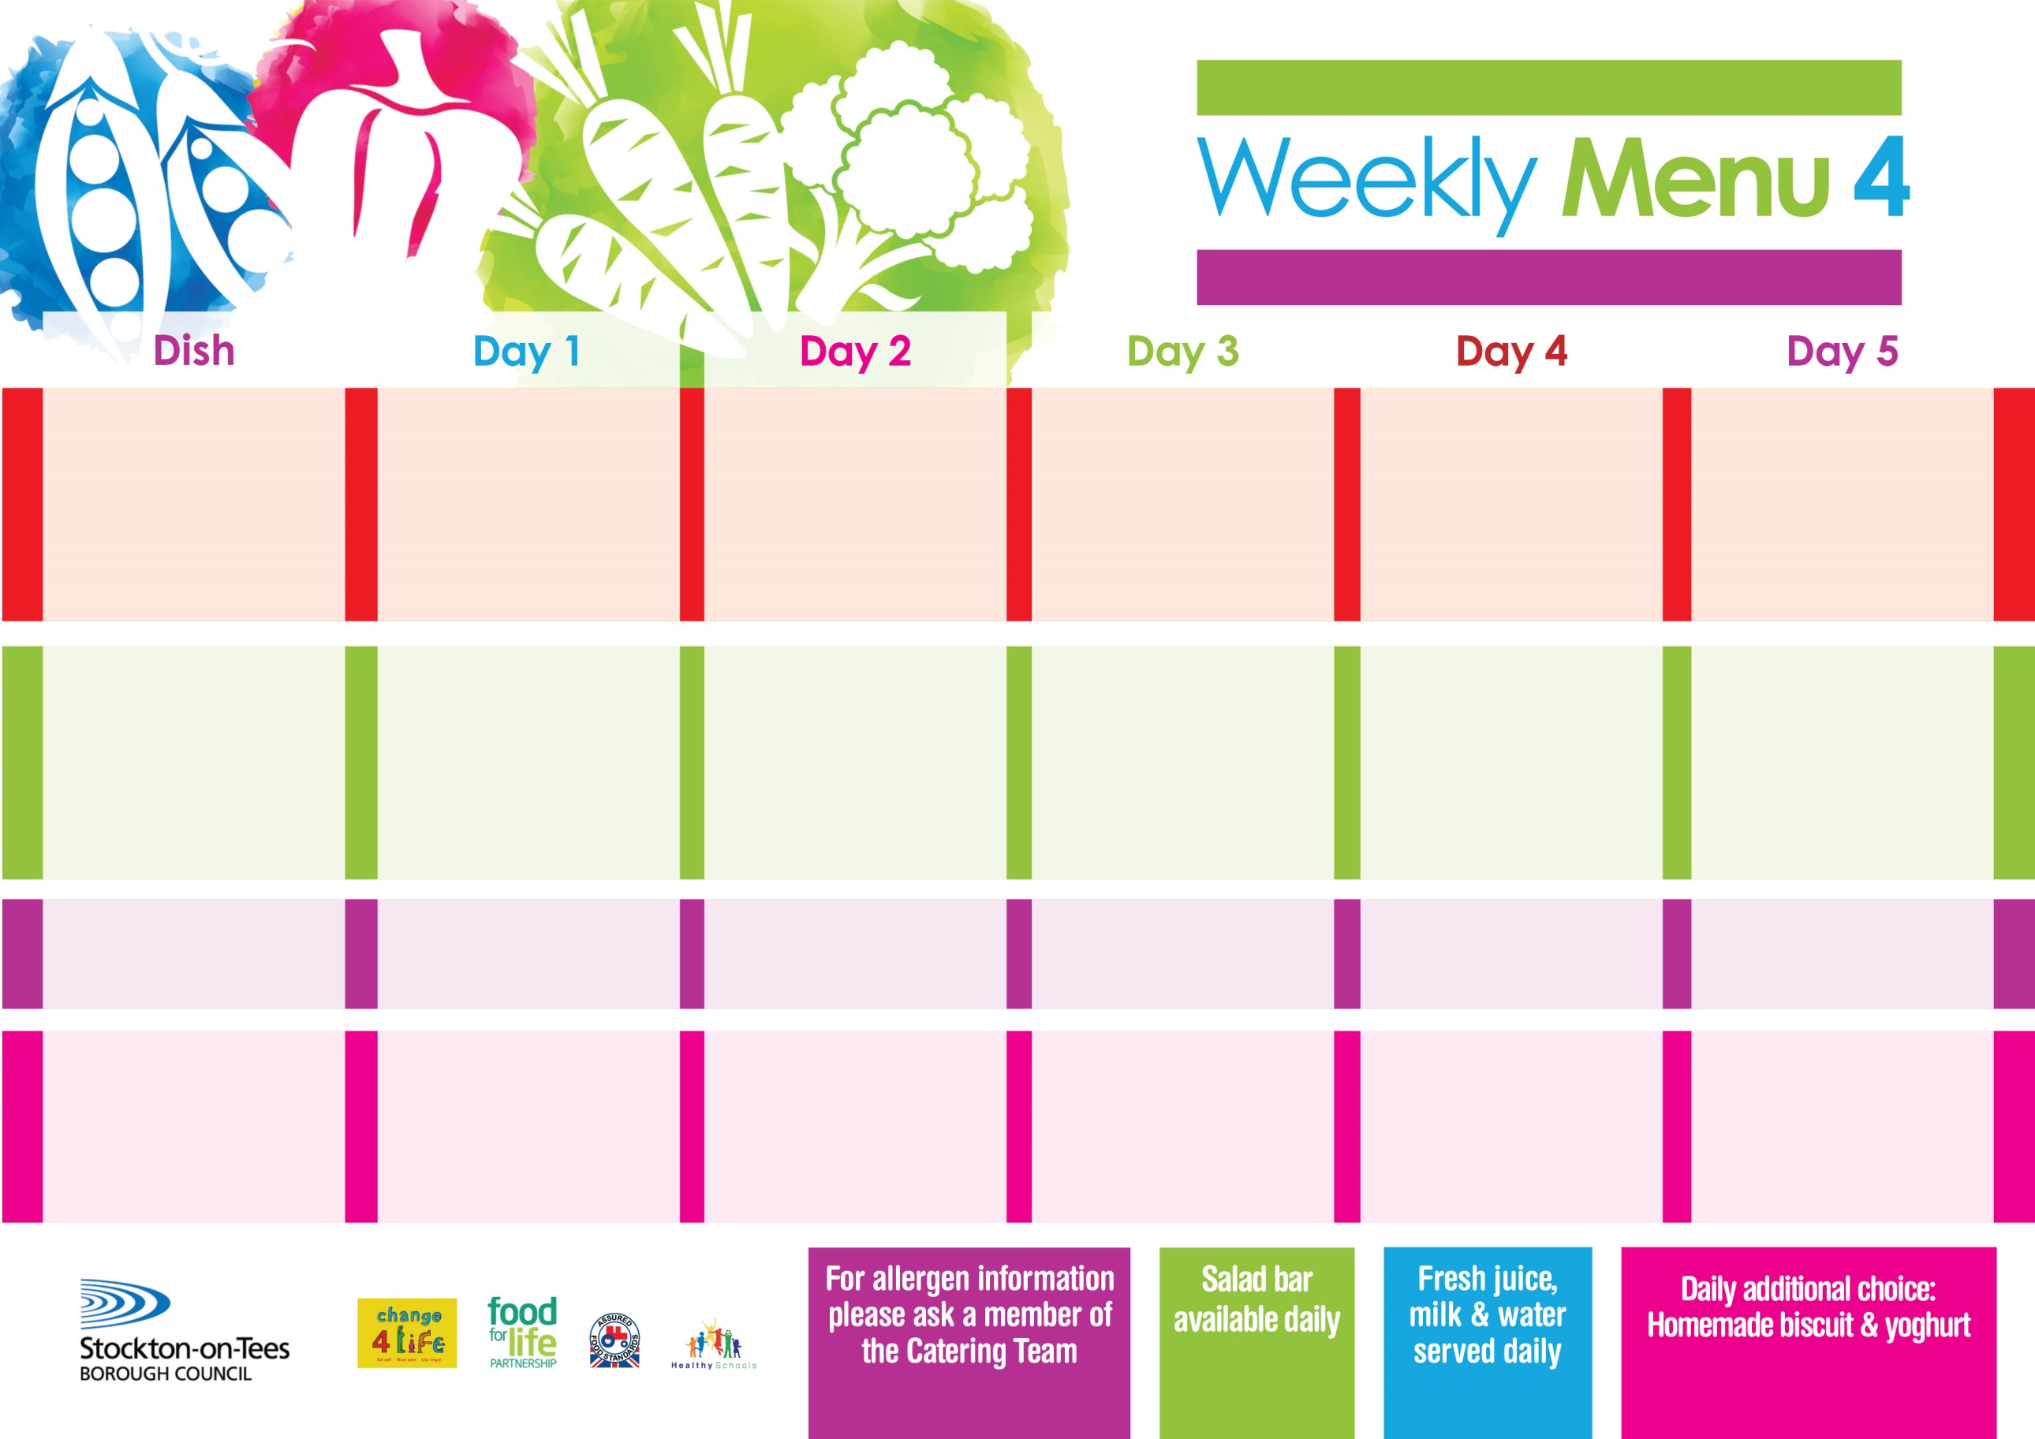

**16th May, 20th June & 18th July, 2022**

**Toad in the Hole**

**Or**

**Quorn Toad in the Hole(V)**

**Creamed Potatoes**

**Mixed Vegetables**

**Green Beans**

**Fish Fillet Fingers**

**Baked Jacket Potatoes**

**Spaghetti Hoops**

**Variety of Sandwiches**

**Cheese (V), Tuna & Egg (V)**

**Homemade Quiche**

**Marble Sponge**

**with Custard Sauce**

**Cold Bar**

**Melon Boat**

**Chicken Pie**

**Creamed Potatoes**

**Mixed Vegetables**

**Brocccoli**

**Sausage Roll**

**Baked Potato Wedges**

**Spaghetti Hoops**

**Variety of Sandwiches**

**Cheese (V), Tuna & Egg (V)**

**Homemade Quiche**

**Rice Pudding**

**with Jam Sauce**

**Cold Bar**

**Fresh Fruit Bowl**

**Mince & Suet Crust**

**Baby Boiled Potatoes**

**Cabbage**

**Diced Carrots**

**Cheese & Tomato**

**Pasta Bake (V)**

**Homemade Herby Bread**

**Tossed Salad**

**Variety of Sandwiches**

**Cheese (V), Tuna & Egg (V)**

**Homemade Quiche**

**Eve’s Pudding**

**with Custard Sauce**

**Cold Bar**

**Fresh Fruit Salad**

**Fish Goujons**

**Oven Baked Chips**

**Baked Beans**

**Garden Peas**

**Homemade Pizza (V)**

**Oven Baked Chips**

**Baked Beans**

**Garden Peas**

**Variety of Sandwiches**

**Cheese (V), Tuna & Egg (V)**

**Homemade Quiche**

**Orange Sponge**

**with Custard Sauce**

**Cold Bar**

**Fresh Fruit Kebab**

**Beef Burger in a Bun**

**or**

**Quorn Burger in a Bun (V)**

**Oven Roasted Potatoes**

**Baked Beans**

**Homemade Cheese Quiche (V)**

**Oven Roasted Potatoes**

**Baked Beans**

**Variety of Sandwiches**

**Cheese (V), Tuna & Egg (V)**

**Homemade Quiche**

**Jam Roly Poly**

**with Custard Sauce**

**Cold Bar**

**Watermelon Slices**

**Primary School Menus**

**Traditional Fayre**

**Cold Selection**

**Desserts**