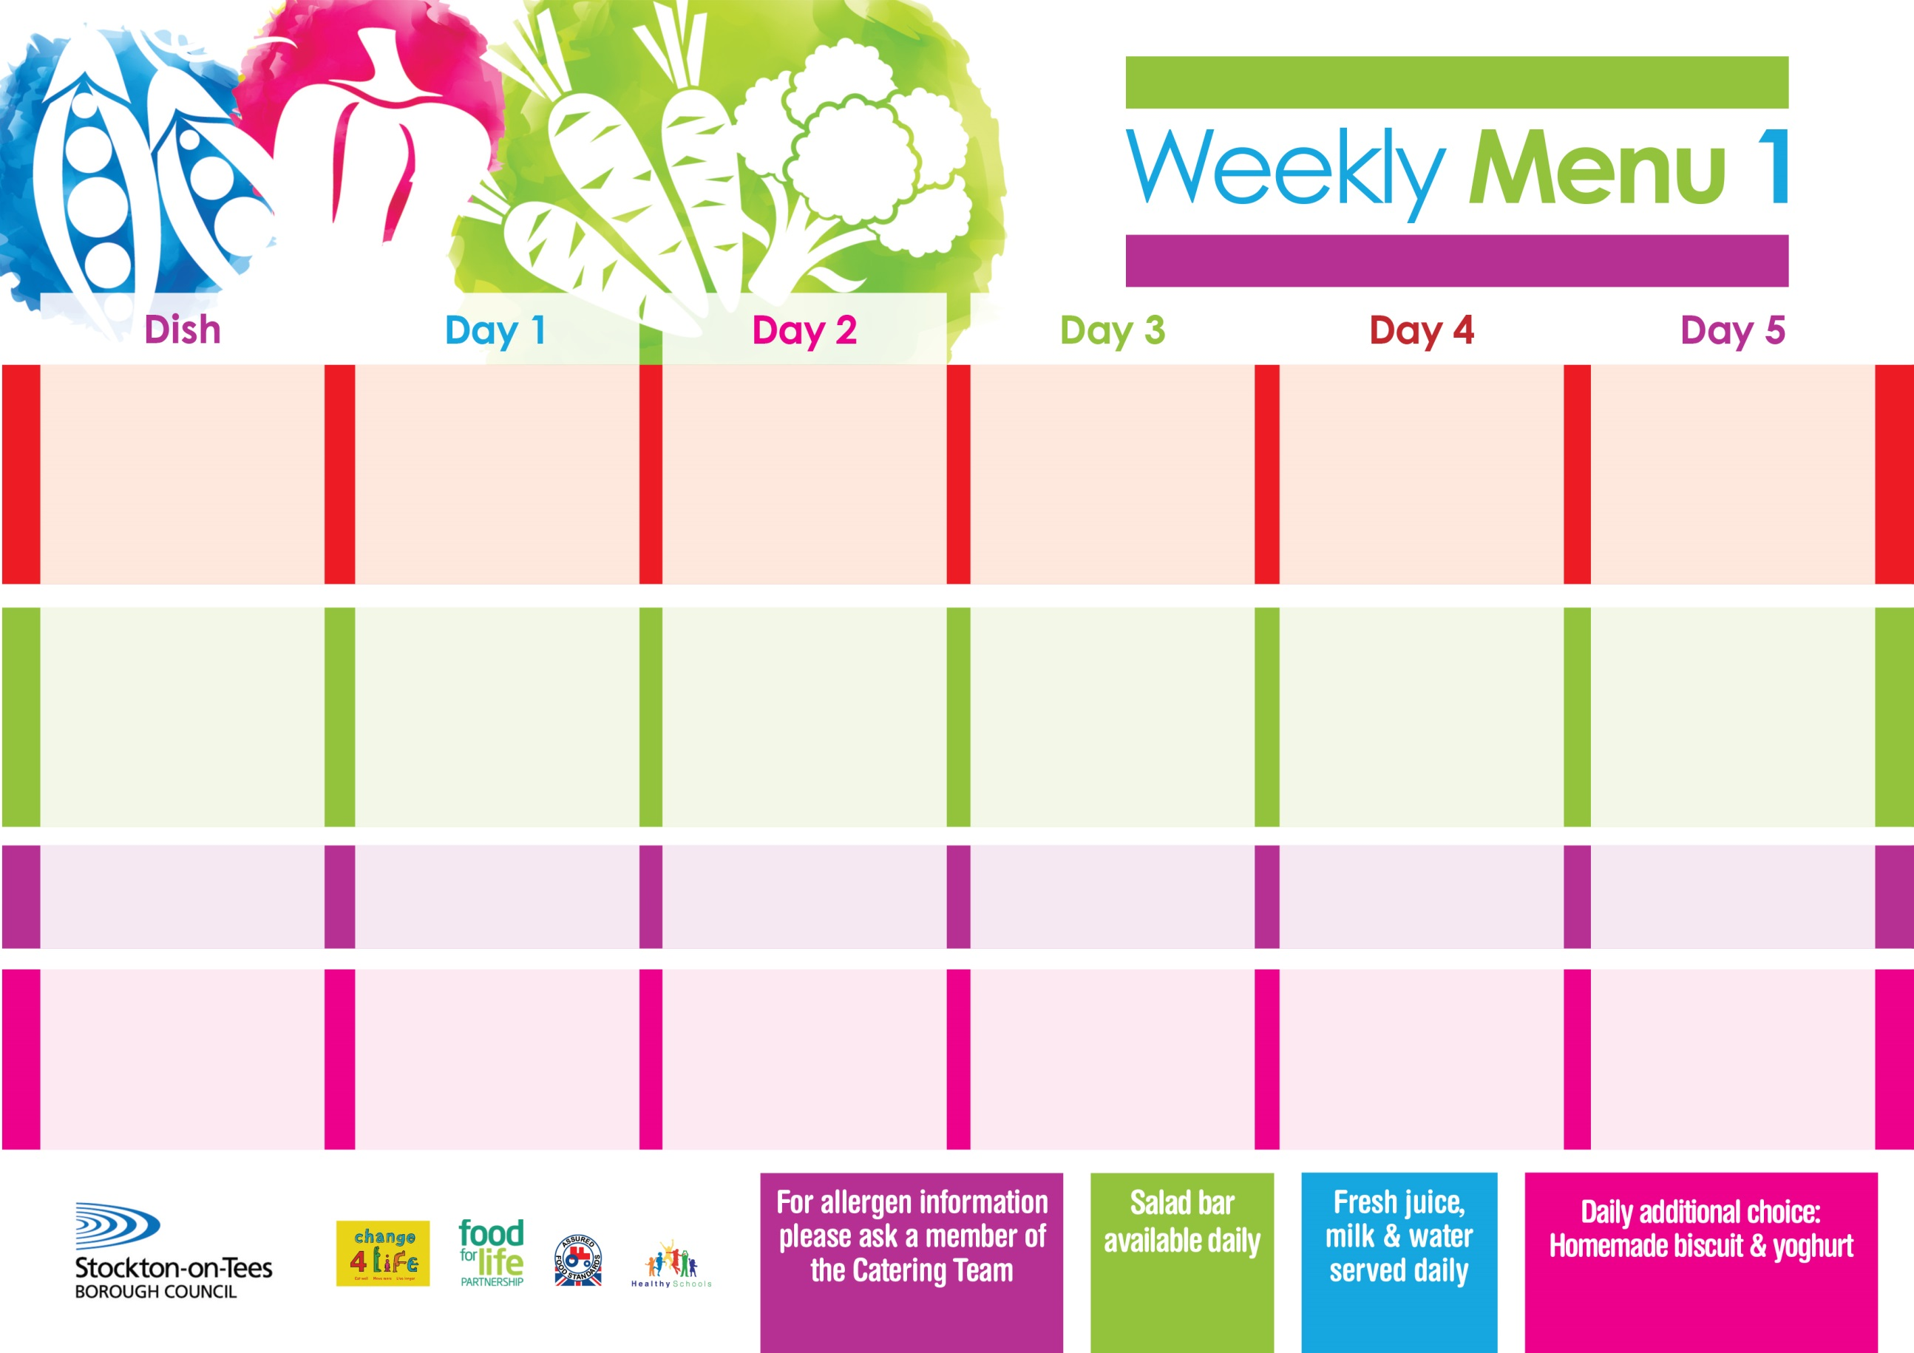

**25th April, 23rd May & 27th June, 2022**

**Spaghetti Bolognaise**

**Homemade Garlic Bread**

**Sweetcorn**

**Baked Cheese**

**& Onion Rolls (V)**

**Baked Potato Wedges**

**Spaghetti Hoops**

**Variety of Sandwiches**

**Cheese (V), Tuna & Egg (V)**

**Homemade Quiche**

**Cornflake Tart**

**with Custard Sauce**

**Cold Bar**

**Watermelon Slices**

**Minced Beef Pie**

**Creamed Potatoes**

**Diced Carrots**

**Broccoli**

**Cheese Omelette (V)**

**Oven Roasted Potatoes**

**Tossed Salad**

**Baked Beans**

**Variety of Sandwiches**

**Cheese (V), Tuna & Egg (V)**

**Homemade Quiche**

**Chocolate Sponge**

**with Custard Sauce**

**Cold Bar**

**Melon Boat**

**Chicken Cobbler**

**Baby Boiled Potatoes**

**Cabbage**

**Diced Swede**

**Jacket Potato filled with Tuna, Cheese (V) or Baked Beans** **(V)**

**Variety of Sandwiches**

**Cheese (V), Tuna & Egg (V)**

**Homemade Quiche**

**Rice Pudding**

**with Jam Sauce**

**Cold Bar**

**Fresh Fruit Salad**

**Fish Goujons**

**Oven Baked Chips**

**Garden Peas**

**Bake Beans**

**Cheese & Tomato Pizza (V)**

**Oven Baked Chips**

**Garden Peas**

**Bake Beans**

**Variety of Sandwiches**

**Cheese (V), Tuna & Egg (V)**

**Homemade Quiche**

**Vanilla Sponge**

**with Custard Sauce**

**Cold Bar**

**Fresh Fruit Platter**

**Pork & Carrot Meatballs in Tomato Sauce**

**Or**

**Quorn Meatballs (v)**

**Served with Pasta Twirls**

**Garden Peas**

**Cauliflower**

**Fish Stars**

**Baked Jacket Potatoes**

**Garden Peas**

**Spaghetti Hoops**

**Variety of Sandwiches**

**Cheese (V), Tuna & Egg (V)**

**Homemade Quiche**

**Apple Crumble**

**with Custard Sauce**

**Cold Bar**

**Fresh Fruit Bowl**

**Primary School Menus**

**Traditional Fayre**

**Cold Selection**

**Desserts**