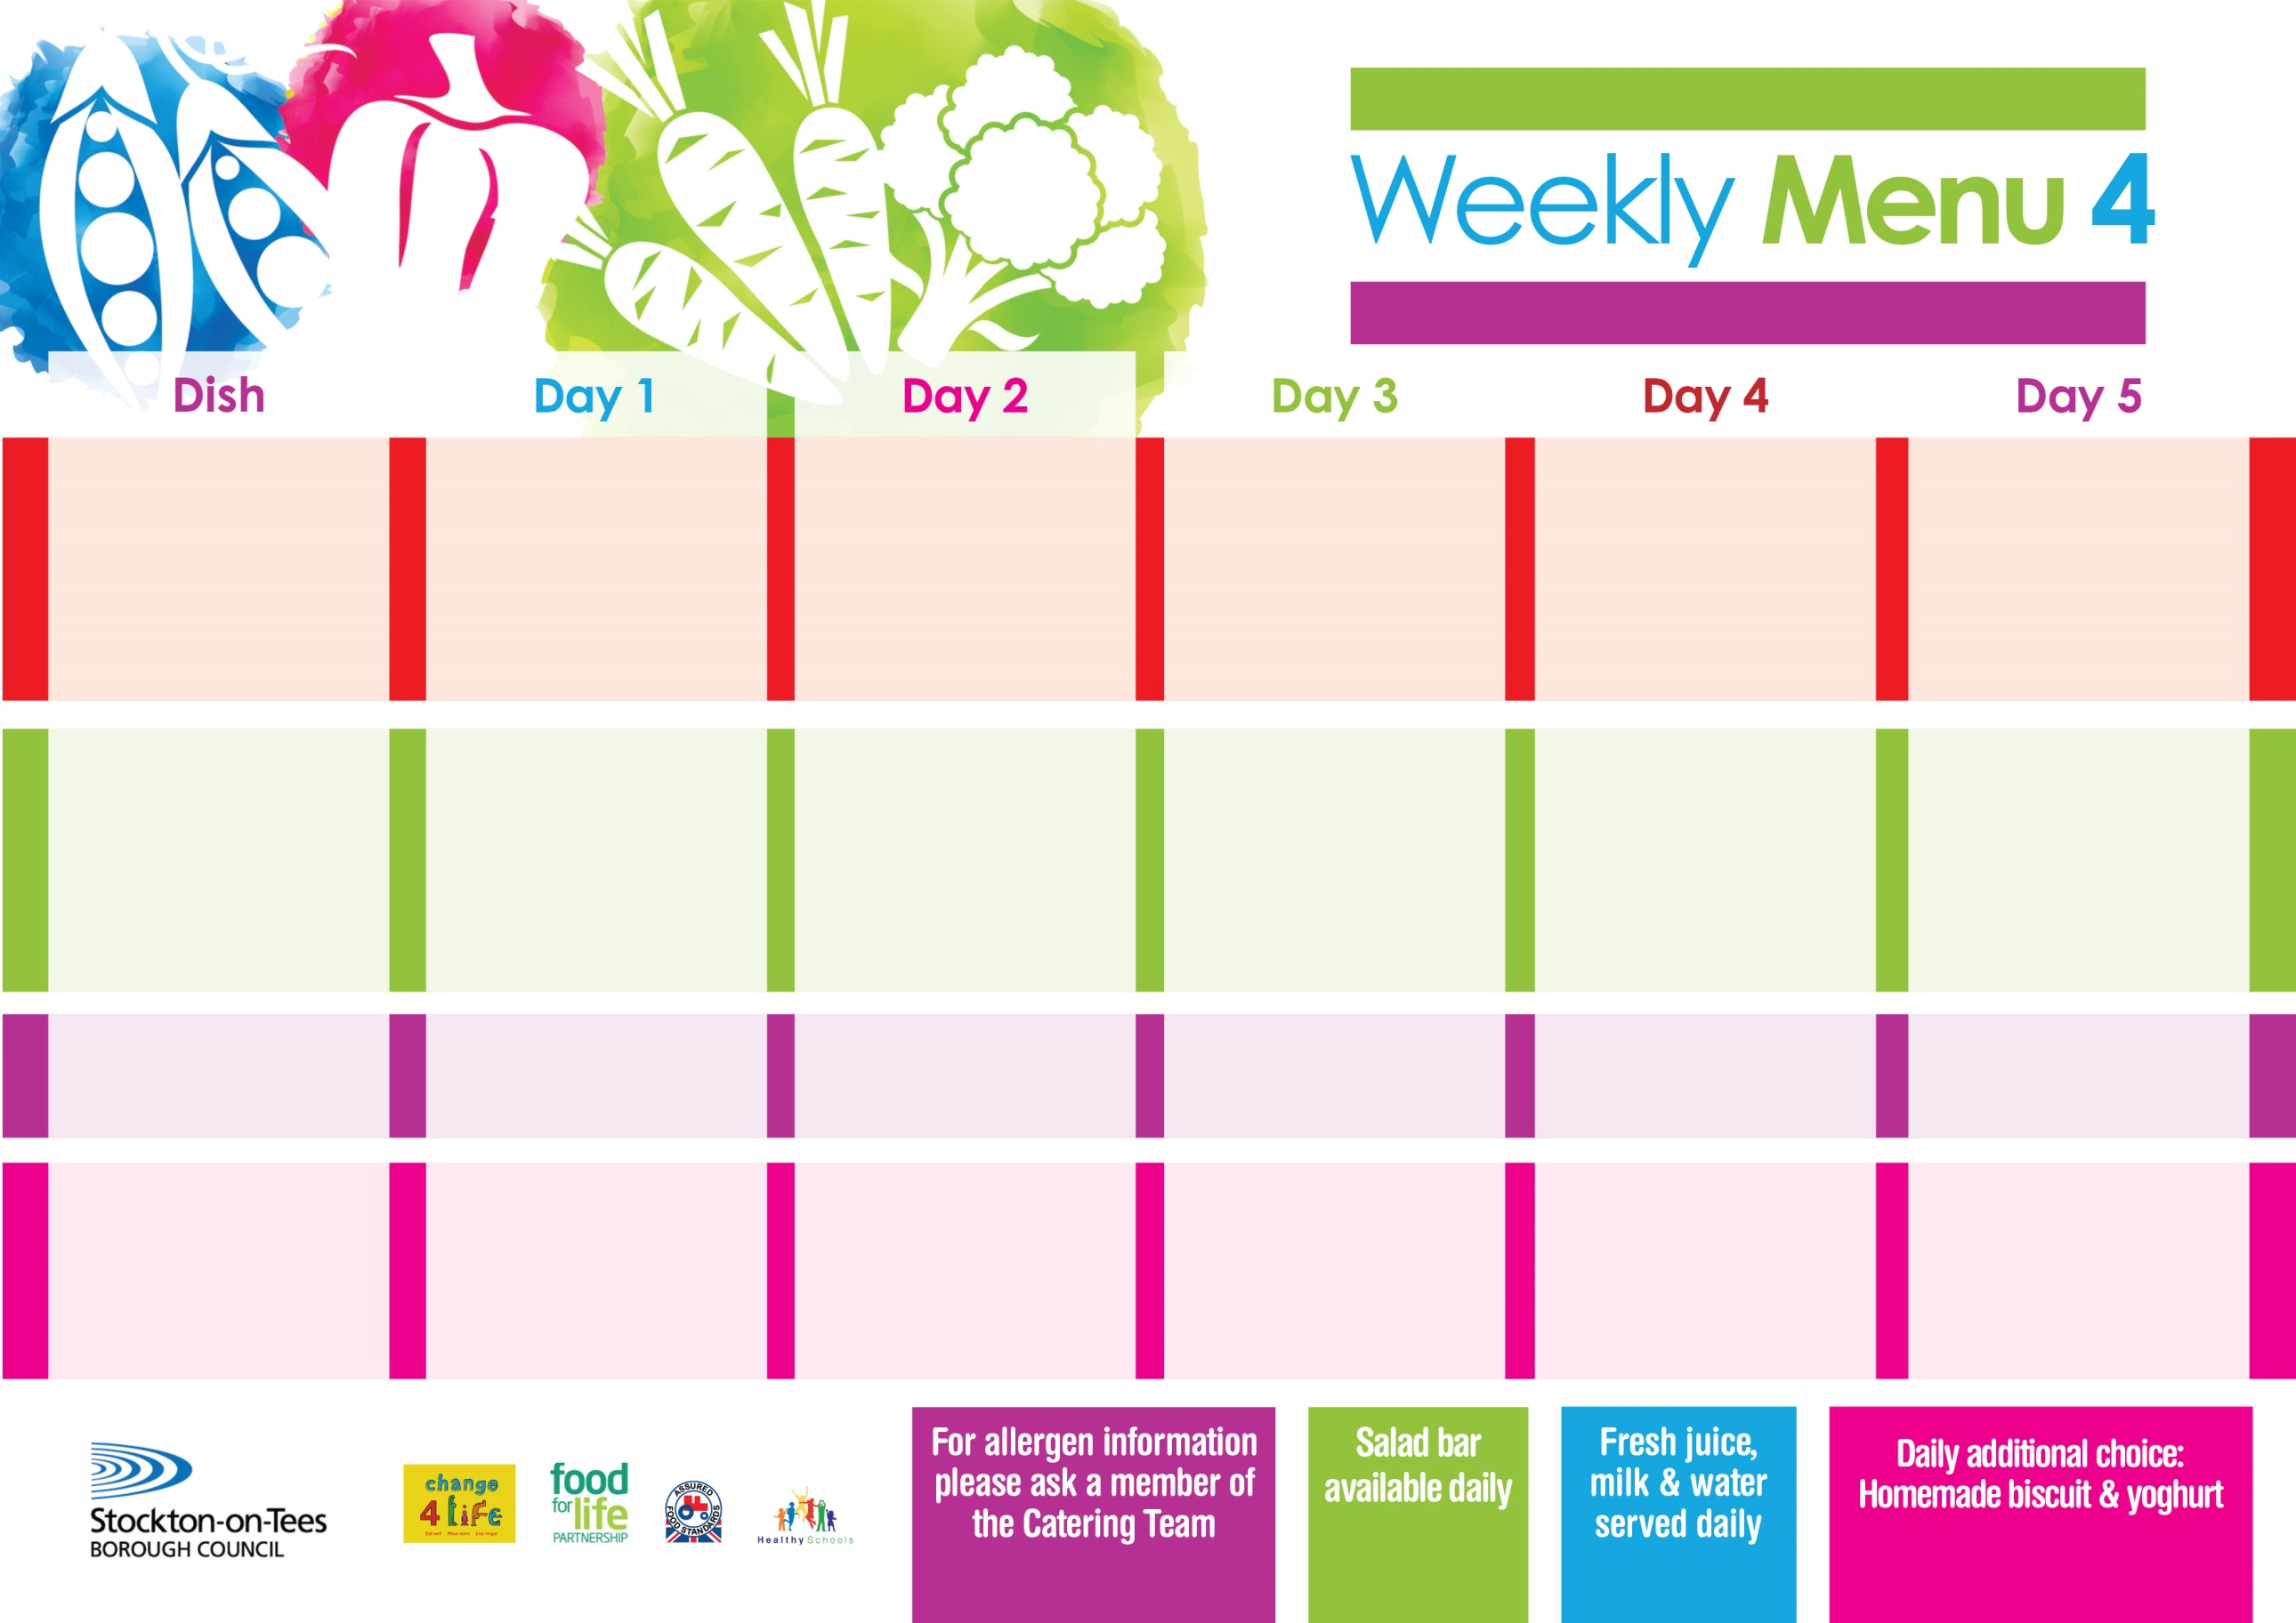

**6th May, 10th June & 8th July, 2024**

**Mince & Dumplings**

**Creamed Potatoes**

**Diced Carrots**

**Broccoli**

**OR**

**Quorn Meatballs (V)**

**Cheese Slices(V)**

**Baked Jacket Potatoes**

**Diced Carrots**

**Broccoli**

**Variety of Sandwiches**

**Eve’s Pudding**

**with Custard Sauce**

**Cold Bar**

**Fresh Fruit**

**Lasagne**

**Homemade Garlic Bread**

**Tossed Salad**

**Coleslaw**

**or**

**Quorn Lasagne (V)**

**Fish Stars**

**Oven Roasted Potatoes**

**Sweetcorn**

**Homemade Quiche(V)**

**Variety of Sandwiches**

**Orange Sponge**

**with Custard Sauce**

**Cold Bar**

**Fresh Fruit**

**Chicken Curry**

**served with Rice**

**Mixed Vegetables**

**Quorn Meatballs (V)**

**Pork & Carrot Meatballs with Pasta in Tomato Sauce**

**Mixed Vegetables**

**Homemade Quiche (V)**

**Variety of Sandwiches**

**Cornflake Tart**

**with Custard Sauce**

**Cold Bar**

**Fresh Fruit**

**Harry Ramsden Fish Fillet**

**Oven Baked Chips**

**Baked Beans**

**Garden Peas**

**Pizza (V)**

**Oven Baked Chips**

**Baked Beans/Garden Peas**

**Homemade Quiche (V)**

**Variety of Sandwiches**

**Syrup Sponge**

**with Custard Sauce**

**Cold Bar**

**Fresh Fruit**

**Cheese & Tomato Pizza (V)**

**Oven Roasted Potatoes**

**Baked Beans**

**Sweetcorn**

**Jacket Potato filled with Tuna, Cheese (V) or Baked Beans (V)**

**Homemade Quiche (V)**

**Variety of Sandwiches**

**Creamy Rice Pudding**

**with Jam Sauce**

**Cold Bar**

**Fresh Fruit**

**Primary School Menus**

**Traditional Fayre**

**Cold Selection**

**Desserts**