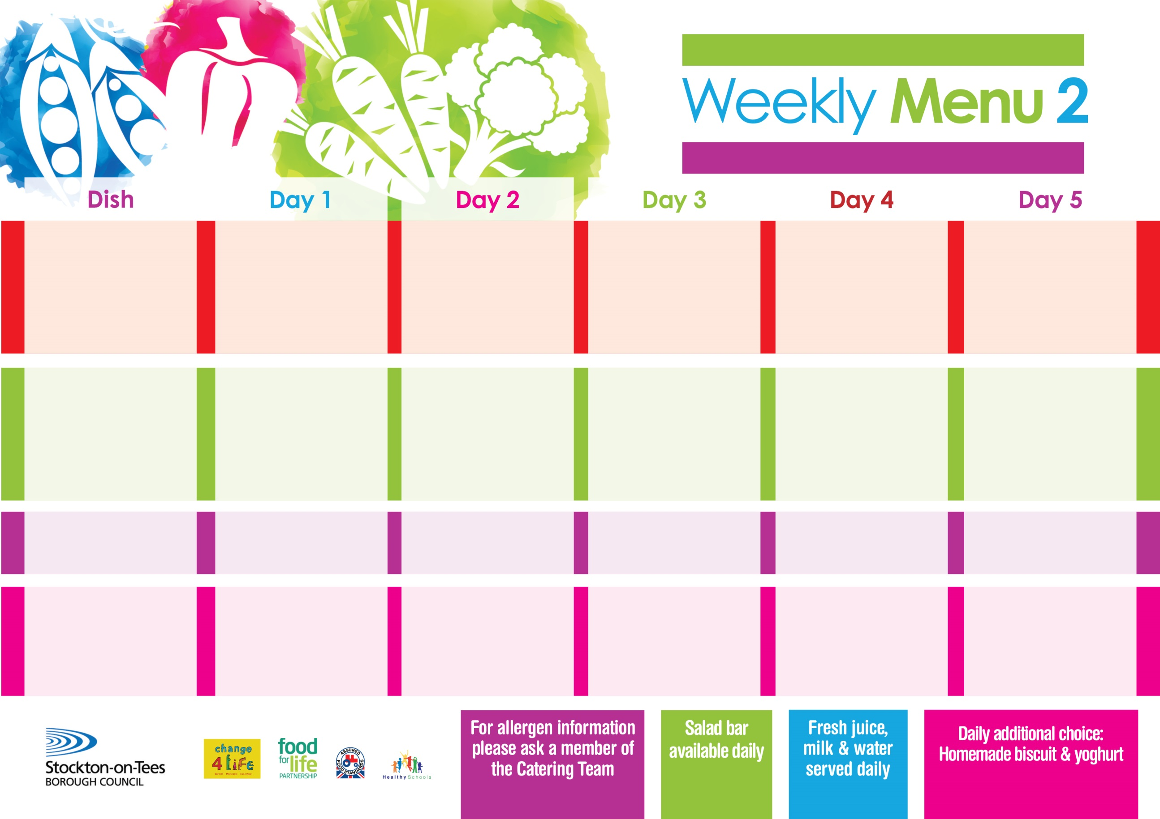

**8th January, 5th February & 11th March, 2024**

**Lasagne**

**Homemade Garlic Bread**

**Tossed Salad & Coleslaw**

**Quorn Lasagne**

**(V)**

**Jacket Potato filled with Tuna, Cheese (V) or Baked Beans (V)**

**Variety of Sandwiches**

**Cheese (V), Tuna & Egg (V)**

**Festival Shortcake**

**with Custard Sauce**

**Cold Bar**

**Fresh Fruit Salad**

**Homemade Pizza (V)**

**Baked Potato Wedges**

**Spaghetti Hoops**

**Macaroni Cheese (V)**

**Homemade Herby Bread**

**Garden Peas**

**Variety of Sandwiches**

**Cheese (V), Tuna & Egg (V)**

**Chocolate Chip Sponge**

**with Custard Sauce**

**Cold Bar**

**Fresh Fruit Bowl**

**Sausage in a Bun**

**Oven Roasted Potatoes**

**Baked Beans**

**Sweetcorn**

**Quorn Sausage in a Bun** **(V)**

**Tomato pasta (V)**

**Oven Roasted Potatoes**

**Baked Beans**

**Sweetcorn**

**Variety of Sandwiches**

**Cheese (V), Tuna & Egg (V)**

**Eve’s Pudding**

**with Custard Sauce**

**Cold Bar**

**Fresh Fruit Bowl**

**Cheese Omelette**

**Mixed Vegetables**

**or**

**Sweet & Sour Quorn (V)**

**Fish Fillet Fingers**

**Baked Jacket Potatoes**

**Baked Beans**

**Variety of Sandwiches**

**Cheese (V), Tuna & Egg (V)**

**Cornflake Tart**

**with Custard Sauce**

**Cold Bar**

**Fresh Fruit Salad**

**Fish Goujons**

**Oven Baked Chips**

**Baked Beans**

**Garden Peas**

**Pizza (V)**

**Oven Baked Chips**

**Baked Beans**

**Garden Peas**

**Variety of Sandwiches**

**Cheese (V), Tuna & Egg (V)**

**Homemade Quiche**

**Creamy Rice Pudding**

**with Jam Sauce**

**Cold Bar**

**Fresh Fruit Bowl**

**Primary School Menus**

**Traditional Fayre**

**Cold Selection**

**Desserts**