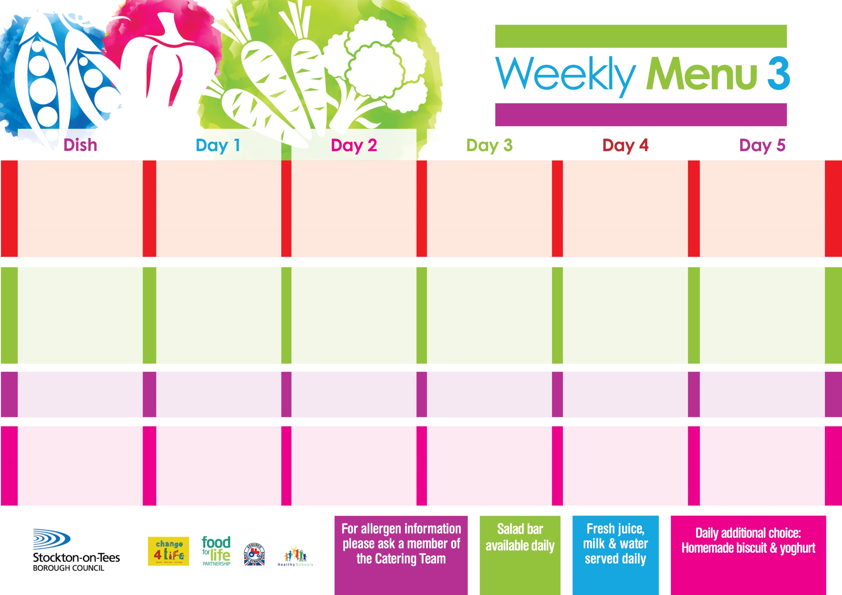

**29th April, 3rd June & 1st July, 2024**

**Chicken Casserole & Dumplings**

**Creamed Potatoes**

**Cauliflower/Swede**

**Fish Stars**

**Baked Jacket Potato**

**Spaghetti Hoops**

**Homemade Quiche (V)**

**Variety of Sandwiches**

**Syrup Roly Poly**

**with Custard Sauce**

**Cold Bar**

**Fresh Fruit Salad**

**Beef Burger in a Bun**

**Oven Roasted Potatoes**

**Baked Beans**

**Garden Peas**

**Salmon & Sweet**

**Potato Fishcake**

**Oven Roasted Potatoes**

**Baked Beans/Garden Peas**

**Homemade Quiche (V)**

**Variety of Sandwiches**

**Feathered Sponge**

**with Custard Sauce**

**Cold Bar**

**Fresh Fruit Bowl**

**Bolognaise**

**with Cheesy Bread**

**Mixed Vegetables**

**or**

**Quorn Bolognaise (V)**

**Sausage Roll**

**Baked Jacket Potato**

**Spaghetti Hoops**

**Homemade Quiche (V)**

**Variety of Sandwiches**

**Oaty Apple Crumble**

**with Custard Sauce**

**Cold Bar**

**Fresh Fruit Salad**

**Homemade Pizza (V)**

**Oven Baked Chips**

**Baked Beans**

**Garden Peas**

**Fish**

**Tuna, Cheese (V) or Baked Beans (V)**

**Homemade Quiche (V)**

**Variety of Sandwiches**

**Lemon Sponge**

**with Custard Sauce**

**Cold Bar**

**Fresh Fruit Bowl**

**Breaded Chicken Breast**

**Oven Roasted Potatoes**

**Diced Carrots**

**Garden Peas**

**or**

**Quorn Dippers (V)**

**Corned Beef Pie**

**Oven Roasted Potatoes**

**Diced Carrots**

**Garden Peas**

**Homemade Quiche (V)**

**Variety of Sandwiches**

**Marble Sponge**

**with Custard Sauce**

**Cold Bar**

**Fresh Fruit Bowl**

**Primary School Menus**

**Traditional Fayre**

**Cold Selection**

**Desserts**