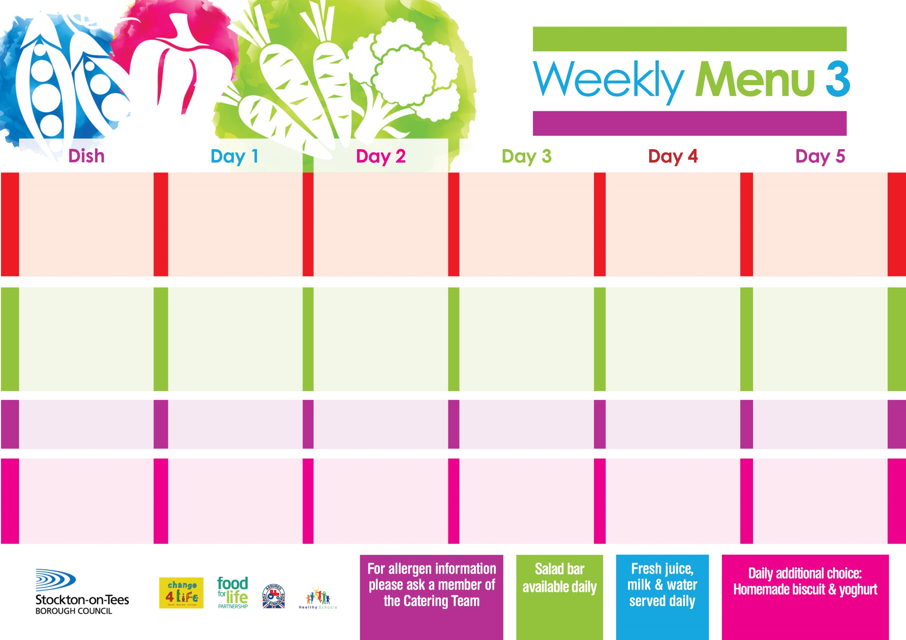

**15th January, 12th February & 18th March, 2024**

**Penne Pasta in**

**Tomato Sauce (V)**

**Homemade Garlic Bread**

**Broccoli**

**Mixed Vegetables**

**Cheese & Onion Roll (V)**

**Jacket Potato**

**Spaghetti Hoops**

**Variety of Sandwiches**

**Cheese (V), Tuna & Egg (V)**

**Syrup Roly Poly**

**with Custard Sauce**

**Cold Bar**

**Fresh Fruit Salad**

**Beef Burger in a Bun**

**Oven Roasted Potatoes**

**Baked Beans**

**Garden Peas**

**Jacket Potato filled with Tuna, Cheese (V) or Baked Beans (V)**

**Variety of Sandwiches**

**Cheese (V), Tuna & Egg (V)**

**Feathered Sponge**

**with Custard Sauce**

**Cold Bar**

**Fresh Fruit Bowl**

**Chicken Pie**

**Creamed Potatoes**

**Diced Carrots**

**Swede**

**Diced Quorn Pie (V)**

**Baked Sausages**

**Baked Potato Wedges**

**Baked Beans**

**Variety of Sandwiches**

**Cheese (V), Tuna & Egg (V)**

**Oaty Apple Crumble**

**with Custard Sauce**

**Cold Bar**

**Fresh Fruit Salad**

**Salmon & Sweet**

**Potato Fishcake**

**Chips**

**Garden Peas**

**Baked Beans**

**Homemade Pizza (V)**

**Oven Baked Chips**

**Baked Beans**

**Garden Peas**

**Variety of Sandwiches**

**Cheese (V), Tuna & Egg (V)**

**Homemade Quiche**

**Lemon Sponge**

**with Custard Sauce**

**Cold Bar**

**Fresh Fruit Bowl**

**Pork & Carrot Meatballs**

**in Gravy**

**Baby Boiled Potatoes**

**Cauliflower**

**Green Beans**

**Quorn Meatballs in Gravy (V)**

**Fishcake**

**Baby Potatoes**

**Spaghetti Hoops**

**Variety of Sandwiches**

**Cheese (V), Tuna & Egg (V)**

**Marble Sponge**

**with Custard Sauce**

**Cold Bar**

**Fresh Fruit Bowl**

**Primary School Menus**

**Traditional Fayre**

**Cold Selection**

**Desserts**